What is Microsoft Entra ID?

New name for Azure Active Directory

<https://www.microsoft.com/en-in/security/business/identity-access/microsoft-entra-id?rtc=1>

Microsoft Entra ID is a cloud-based identity and access management service that enables your employees access external resources. Example resources include Microsoft 365, the Azure portal, and thousands of other SaaS applications.

Microsoft Entra ID also helps them access internal resources like apps on your corporate intranet, and any cloud apps developed for your own organization. To learn how to create a tenant, see [Quickstart: Create a new tenant in Microsoft Entra ID](https://learn.microsoft.com/en-us/entra/fundamentals/create-new-tenant).

To learn the differences between Active Directory and Microsoft Entra ID, see [Compare Active Directory to Microsoft Entra ID](https://learn.microsoft.com/en-us/entra/fundamentals/compare). You can also refer to [Microsoft Cloud for Enterprise Architects Series](https://learn.microsoft.com/en-us/microsoft-365/solutions/cloud-architecture-models) posters to better understand the core identity services in Azure like Microsoft Entra ID and Microsoft-365

## Who uses Microsoft Entra ID?

Microsoft Entra ID provides different benefits to members of your organization based on their role:

* **IT admins** use Microsoft Entra ID to control access to apps and app resources, based on business requirements. For example, as an IT admin, you can use Microsoft Entra ID to require multi-factor authentication when accessing important organizational resources. You could also use Microsoft Entra ID to automate user provisioning between your existing Windows Server AD and your cloud apps, including Microsoft 365. Finally, Microsoft Entra ID gives you powerful tools to automatically help protect user identities and credentials and to meet your access governance requirements. To get started, sign up for a [free 30-day Microsoft Entra ID P1 or P2 trial](https://azure.microsoft.com/trial/get-started-active-directory/).
* **App developers** can use Microsoft Entra ID as a standards-based authentication provider that helps them add single sign-on (SSO) to apps that works with a user's existing credentials. Developers can also use Microsoft Entra APIs to build personalized experiences using organizational data. To get started, sign up for a [free 30-day Microsoft Entra ID P1 or P2 trial](https://azure.microsoft.com/trial/get-started-active-directory/). For more information, you can also see [Microsoft Entra ID for developers](https://learn.microsoft.com/en-us/entra/identity-platform/).
* **Microsoft 365, Office 365, Azure, or Dynamics CRM Online subscribers** already use Microsoft Entra ID as every Microsoft 365, Office 365, Azure, and Dynamics CRM Online tenant is automatically a Microsoft Entra tenant. You can immediately start managing access to your integrated cloud apps.

## What are the Microsoft Entra ID licenses?

Microsoft Online business services, such as Microsoft 365 or Microsoft Azure, use Microsoft Entra ID for sign-in activities and to help protect your identities. If you subscribe to any Microsoft Online business service, you automatically get access to [Microsoft Entra ID Free](https://www.microsoft.com/security/business/identity-access/azure-active-directory-pricing).

To enhance your Microsoft Entra implementation, you can also add paid features by upgrading to Microsoft Entra ID P1 or Premium P2 licenses. Microsoft Entra paid licenses are built on top of your existing free directory. The licenses provide self-service, enhanced monitoring, security reporting, and secure access for your mobile users.

**Note**

For the pricing options of these licenses, see [**Microsoft Entra pricing**](https://www.microsoft.com/security/business/identity-access-management/azure-ad-pricing).

For more information about Microsoft Entra pricing, contact the [**Microsoft Entra Forum**](https://azure.microsoft.com/support/community/?product=active-directory).

* **Microsoft Entra ID Free.** Provides user and group management, on-premises directory synchronization, basic reports, self-service password change for cloud users, and single sign-on across Azure, Microsoft 365, and many popular SaaS apps.
* **Microsoft Entra ID P1.** In addition to the Free features, P1 also lets your hybrid users access both on-premises and cloud resources. It also supports advanced administration, such as dynamic groups, self-service group management, Microsoft Identity Manager, and cloud write-back capabilities, which allow self-service password reset for your on-premises users.
* **Microsoft Entra ID P2.** In addition to the Free and P1 features, P2 also offers [Microsoft Entra ID Protection](https://learn.microsoft.com/en-us/entra/id-protection/overview-identity-protection) to help provide risk-based Conditional Access to your apps and critical company data and [Privileged Identity Management](https://learn.microsoft.com/en-us/entra/id-governance/privileged-identity-management/pim-getting-started) to help discover, restrict, and monitor administrators and their access to resources and to provide just-in-time access when needed.
* **"Pay as you go" feature licenses.** You can also get licenses for features such as, Microsoft Entra Business-to-Customer (B2C). B2C can help you provide identity and access management solutions for your customer-facing apps. For more information, see [Azure Active Directory B2C documentation](https://learn.microsoft.com/en-us/azure/active-directory-b2c/).

For more information about associating an Azure subscription to Microsoft Entra ID, see [Associate or add an Azure subscription to Microsoft Entra ID](https://learn.microsoft.com/en-us/entra/fundamentals/how-subscriptions-associated-directory). For more information about assigning licenses to your users, see [How to: Assign or remove Microsoft Entra ID licenses](https://learn.microsoft.com/en-us/entra/fundamentals/license-users-groups).

## What are the Microsoft Entra ID licenses?

Microsoft Online business services, such as Microsoft 365 or Microsoft Azure, use Microsoft Entra ID for sign-in activities and to help protect your identities. If you subscribe to any Microsoft Online business service, you automatically get access to [Microsoft Entra ID Free](https://www.microsoft.com/security/business/identity-access/azure-active-directory-pricing).

To enhance your Microsoft Entra implementation, you can also add paid features by upgrading to Microsoft Entra ID P1 or Premium P2 licenses. Microsoft Entra paid licenses are built on top of your existing free directory. The licenses provide self-service, enhanced monitoring, security reporting, and secure access for your mobile users.

**Note**

For the pricing options of these licenses, see [**Microsoft Entra pricing**](https://www.microsoft.com/security/business/identity-access-management/azure-ad-pricing).

For more information about Microsoft Entra pricing, contact the [**Microsoft Entra Forum**](https://azure.microsoft.com/support/community/?product=active-directory).

* **Microsoft Entra ID Free.** Provides user and group management, on-premises directory synchronization, basic reports, self-service password change for cloud users, and single sign-on across Azure, Microsoft 365, and many popular SaaS apps.
* **Microsoft Entra ID P1.** In addition to the Free features, P1 also lets your hybrid users access both on-premises and cloud resources. It also supports advanced administration, such as dynamic groups, self-service group management, Microsoft Identity Manager, and cloud write-back capabilities, which allow self-service password reset for your on-premises users.
* **Microsoft Entra ID P2.** In addition to the Free and P1 features, P2 also offers [Microsoft Entra ID Protection](https://learn.microsoft.com/en-us/entra/id-protection/overview-identity-protection) to help provide risk-based Conditional Access to your apps and critical company data and [Privileged Identity Management](https://learn.microsoft.com/en-us/entra/id-governance/privileged-identity-management/pim-getting-started) to help discover, restrict, and monitor administrators and their access to resources and to provide just-in-time access when needed.
* **"Pay as you go" feature licenses.** You can also get licenses for features such as, Microsoft Entra Business-to-Customer (B2C). B2C can help you provide identity and access management solutions for your customer-facing apps. For more information, see [Azure Active Directory B2C documentation](https://learn.microsoft.com/en-us/azure/active-directory-b2c/).

For more information about associating an Azure subscription to Microsoft Entra ID, see [Associate or add an Azure subscription to Microsoft Entra ID](https://learn.microsoft.com/en-us/entra/fundamentals/how-subscriptions-associated-directory). For more information about assigning licenses to your users, see [How to: Assign or remove Microsoft Entra ID licenses](https://learn.microsoft.com/en-us/entra/fundamentals/license-users-groups).

## Which features work in Microsoft Entra ID?

After you choose your Microsoft Entra ID license, you'll get access to some or all of the following features:

| **Category** | **Description** |
| --- | --- |
| Application management | Manage your cloud and on-premises apps using Application Proxy, single sign-on, the My Apps portal, and Software as a Service (SaaS) apps. For more information, see [How to provide secure remote access to on-premises applications](https://learn.microsoft.com/en-us/entra/identity/app-proxy/application-proxy) and [Application Management documentation](https://learn.microsoft.com/en-us/entra/identity/enterprise-apps/). |
| Authentication | Manage Microsoft Entra self-service password reset, Multi-Factor Authentication, custom banned password list, and smart lockout. For more information, see [Microsoft Entra authentication documentation](https://learn.microsoft.com/en-us/entra/identity/authentication/). |
| Microsoft Entra ID for developers | Build apps that sign in all Microsoft identities, get tokens to call Microsoft Graph, other Microsoft APIs, or custom APIs. For more information, see [Microsoft identity platform (Microsoft Entra ID for developers)](https://learn.microsoft.com/en-us/entra/identity-platform/). |
| Business-to-Business (B2B) | Manage your guest users and external partners, while maintaining control over your own corporate data. For more information, see [Microsoft Entra B2B documentation](https://learn.microsoft.com/en-us/entra/external-id/). |
| Business-to-Customer (B2C) | Customize and control how users sign up, sign in, and manage their profiles when using your apps. For more information, see [Azure Active Directory B2C documentation](https://learn.microsoft.com/en-us/azure/active-directory-b2c/). |
| Conditional Access | Manage access to your cloud apps. For more information, see [Microsoft Entra Conditional Access documentation](https://learn.microsoft.com/en-us/entra/identity/conditional-access/). |
| Device Management | Manage how your cloud or on-premises devices access your corporate data. For more information, see [Microsoft Entra Device Management documentation](https://learn.microsoft.com/en-us/entra/identity/devices/). |
| Domain services | Join Azure virtual machines to a domain without using domain controllers. For more information, see [Microsoft Entra Domain Services documentation](https://learn.microsoft.com/en-us/entra/identity/domain-services/). |
| Enterprise users | Manage license assignments, access to apps, and set up delegates using groups and administrator roles. For more information, see [Microsoft Entra user management documentation](https://learn.microsoft.com/en-us/entra/identity/users/). |
| Hybrid identity | Use Microsoft Entra Connect and Connect Health to provide a single user identity for authentication and authorization to all resources, regardless of location (cloud or on-premises). For more information, see [Hybrid identity documentation](https://learn.microsoft.com/en-us/entra/identity/hybrid/). |
| Identity governance | Manage your organization's identity through employee, business partner, vendor, service, and app access controls. You can also perform access reviews. For more information, see [Microsoft Entra ID Governance documentation](https://learn.microsoft.com/en-us/entra/id-governance/identity-governance-overview) and [Microsoft Entra access reviews](https://learn.microsoft.com/en-us/entra/id-governance/access-reviews-overview). |
| Identity protection | Detect potential vulnerabilities affecting your organization's identities, configure policies to respond to suspicious actions, and then take appropriate action to resolve them. For more information, see [Microsoft Entra ID Protection](https://learn.microsoft.com/en-us/entra/id-protection/). |
| Managed identities for Azure resources | Provide your Azure services with an automatically managed identity in Microsoft Entra ID that can authenticate any Microsoft Entra ID-supported authentication service, including Key Vault. For more information, see [What is managed identities for Azure resources?](https://learn.microsoft.com/en-us/entra/identity/managed-identities-azure-resources/overview). |
| Privileged identity management (PIM) | Manage, control, and monitor access within your organization. This feature includes access to resources in Microsoft Entra ID and Azure, and other Microsoft Online Services, like Microsoft 365 or Intune. For more information, see [Microsoft Entra Privileged Identity Management](https://learn.microsoft.com/en-us/entra/id-governance/privileged-identity-management/). |
| Monitoring and health | Gain insights into the security and usage patterns in your environment. For more information, see [Microsoft Entra monitoring and health](https://learn.microsoft.com/en-us/entra/identity/monitoring-health/). |
| Workload identities | Give an identity to your software workload (such as an application, service, script, or container) to authenticate and access other services and resources. For more information, see [workload identities faqs](https://learn.microsoft.com/en-us/entra/workload-id/workload-identities-faqs). |

## Terminology

To better understand Microsoft Entra ID and its documentation, we recommend reviewing the following terms.

| **Term or concept** | **Description** |
| --- | --- |
| Identity | A thing that can get authenticated. An identity can be a user with a username and password. Identities also include applications or other servers that might require authentication through secret keys or certificates. |
| Account | An identity that has data associated with it. You can’t have an account without an identity. |
| Microsoft Entra account | An identity created through Microsoft Entra ID or another Microsoft cloud service, such as Microsoft 365. Identities are stored in Microsoft Entra ID and accessible to your organization's cloud service subscriptions. This account is also sometimes called a Work or school account. |
| Account Administrator | This classic subscription administrator role is conceptually the billing owner of a subscription. This role enables you to manage all subscriptions in an account. For more information, see [Azure roles, Microsoft Entra roles, and classic subscription administrator roles](https://learn.microsoft.com/en-us/azure/role-based-access-control/rbac-and-directory-admin-roles). |
| Service Administrator | This classic subscription administrator role enables you to manage all Azure resources, including access. This role has the equivalent access of a user who is assigned the Owner role at the subscription scope. For more information, see [Azure roles, Microsoft Entra roles, and classic subscription administrator roles](https://learn.microsoft.com/en-us/azure/role-based-access-control/rbac-and-directory-admin-roles). |
| Owner | This role helps you manage all Azure resources, including access. This role is built on a newer authorization system called Azure role-based access control (Azure RBAC) that provides fine-grained access management to Azure resources. For more information, see [Azure roles, Microsoft Entra roles, and classic subscription administrator roles](https://learn.microsoft.com/en-us/azure/role-based-access-control/rbac-and-directory-admin-roles). |
| Microsoft Entra Global Administrator | This administrator role is automatically assigned to whomever created the Microsoft Entra tenant. You can have multiple Global Administrators, but only Global Administrators can assign administrator roles (including assigning other Global Administrators) to users. For more information about the various administrator roles, see [Administrator role permissions in Microsoft Entra ID](https://learn.microsoft.com/en-us/entra/identity/role-based-access-control/permissions-reference). |
| Azure subscription | Used to pay for Azure cloud services. You can have many subscriptions and they're linked to a credit card. |
| Azure tenant | A dedicated and trusted instance of Microsoft Entra ID. The tenant is automatically created when your organization signs up for a Microsoft cloud service subscription. These subscriptions include Microsoft Azure, Microsoft Intune, or Microsoft 365. An Azure tenant represents a single organization. |
| Single tenant | Azure tenants that access other services in a dedicated environment are considered single tenant. |
| Multi-tenant | Azure tenants that access other services in a shared environment, across multiple organizations, are considered multi-tenant. |
| Microsoft Entra directory | Each Azure tenant has a dedicated and trusted Microsoft Entra directory. The Microsoft Entra directory includes the tenant's users, groups, and apps and is used to perform identity and access management functions for tenant resources. |
| Custom domain | Every new Microsoft Entra directory comes with an initial domain name, for example domainname.onmicrosoft.com. In addition to that initial name, you can also add your organization's domain names. Your organization's domain names include the names you use to do business and your users use to access your organization's resources, to the list. Adding custom domain names helps you to create user names that are familiar to your users, such as alain@contoso.com. |
| Microsoft account (also called, MSA) | Personal accounts that provide access to your consumer-oriented Microsoft products and cloud services. These products and services include Outlook, OneDrive, Xbox LIVE, or Microsoft 365. Your Microsoft account is created and stored in the Microsoft consumer identity account system that's run by Microsoft. Things to know about Microsoft Entra editions <https://learn.microsoft.com/en-us/training/modules/configure-azure-active-directory/5-select-editions?ns-enrollment-type=learningpath&ns-enrollment-id=learn.az-104-manage-identities-governance>  Consider the following features that distinguish the different editions of Microsoft Entra ID. After you review the features and descriptions, think about which edition works best for your organization. An X indicates the feature is supported.   | **Feature** | **Free** | **Microsoft 365 Apps** | **Premium P1** | **Premium P2** | | --- | --- | --- | --- | --- | | **Directory Objects** | 500,000 | Unlimited | Unlimited | Unlimited | | **Single Sign-on** | Unlimited | Unlimited | Unlimited | Unlimited | | **Core Identity and Access Management** | X | X | X | X | | **Business-to-business Collaboration** | X | X | X | X | | **Identity and Access Management for Microsoft 365 apps** |  | X | X | X | | **Premium Features** |  |  | X | X | | **Hybrid Identities** |  |  | X | X | | **Advanced Group Access Management** |  |  | X | X | | **Conditional Access** |  |  | X | X | | **Identity Protection** |  |  |  | X | | **Identity Governance** |  |  |  | X |  Microsoft Entra ID Free The Free edition provides user and group management, on-premises directory synchronization, and basic reports. Single sign-on access is supported across Azure, Microsoft 365, and many popular SaaS apps. Microsoft Entra Microsoft 365 Apps This edition is included with Microsoft 365. In addition to the Free features, this edition provides Identity and Access Management for Microsoft 365 apps. The extra support includes branding, MFA, group access management, and self-service password reset for cloud users. Microsoft Entra ID P1 In addition to the Free features, the Premium P1 edition lets your hybrid users access both on-premises and cloud resources. This edition supports advanced administration like dynamic groups, self-service group management, and cloud write-back capabilities. P1 also includes Microsoft Identity Manager, an on-premises identity and access management suite. The extra features in P1 allow self-service password reset for your on-premises users. Microsoft Entra ID P2 In addition to the Free and P1 features, the Premium P2 edition offers Microsoft Entra ID Protection to help provide risk-based Conditional Access to your apps and critical company data. Privileged Identity Management is included to help discover, restrict, and monitor administrators and their access to resources, and to provide just-in-time access when needed.  **Tip**  The [**Microsoft Entra pricing**](https://azure.microsoft.com/pricing/details/active-directory) page has detailed information on what's included in each edition. |

What is Microsoft Entra Domain Services?

<https://learn.microsoft.com/en-us/entra/identity/domain-services/overview>

Microsoft Entra Domain Services provides managed domain services such as domain join, group policy, lightweight directory access protocol (LDAP), and Kerberos/NTLM authentication. You use these domain services without the need to deploy, manage, and patch domain controllers (DCs) in the cloud.

managed domain services : Azure will all thing we do not need to take care of it like deleting user , updating the user

A Domain Services managed domain lets you run legacy applications in the cloud that can't use modern authentication methods, or where you don't want directory lookups to always go back to an on-premises AD DS environment. You can lift and shift those legacy applications from your on-premises environment into a managed domain, without needing to manage the AD DS environment in the cloud.

legacy applications : let suppose some service like batabase or employee added in old running in On-Premise. We wan to use this in cloud so we can sync it with cloud. No need to lookup to On-premise AD both are available in cloud .

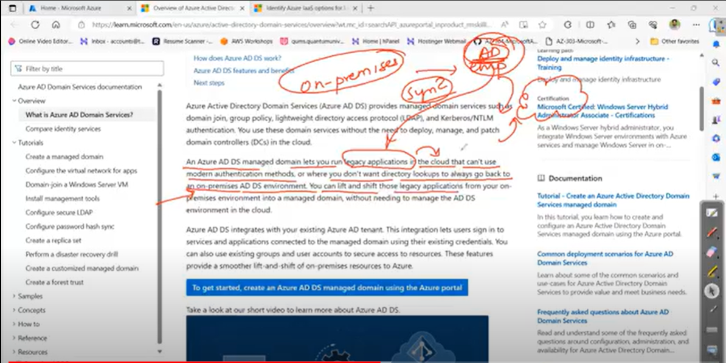

lift and shift : Migration or else we can say Ready to move

Those things which are already ready to move on cloud without doing any changes those are also called Lift and Shift. That mean Lift from On-premise and Shift to Cloud  
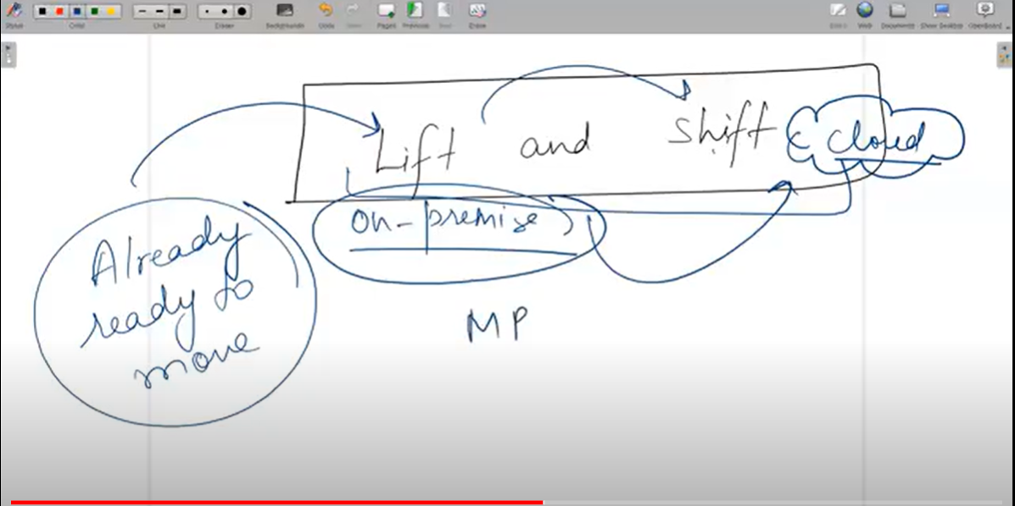

Note : Migration Readiness Assessment (MRA) with help of this tool we can check eighter we able to going to cloud or not

Domain Services integrates with your existing Microsoft Entra tenant. This integration lets users sign in to services and applications connected to the managed domain using their existing credentials. You can also use existing groups and user accounts to secure access to resources. These features provide a smoother lift-and-shift of on-premises resources to Azure.

First we need to find which option we have in Azure Active Directory.

1. Overview :

Here we can see the Name of directory , Tenant Id , Primary domain, License (Currently we are using the free license but for some services we need premium subscription we can see later), Users, Groups, Application connected , Device connect

Also we Add and Manage Tenant these some basics thing we can see.

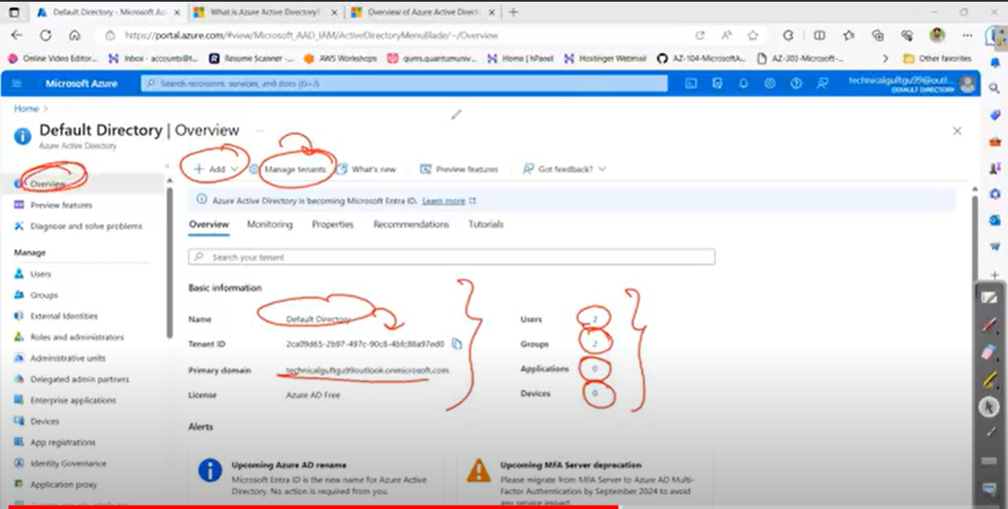

1. Preview features:

We can see features of AD, how can do in Active directory and which feature are available

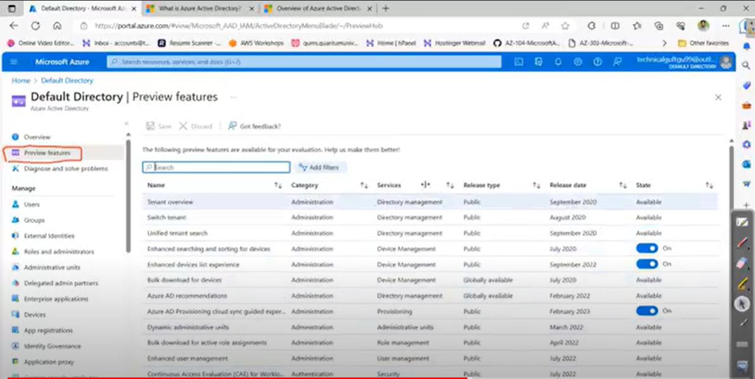

1. Diagnose and solve problems

If some issue is coming in AD and you want to diagnose or trouble shoot

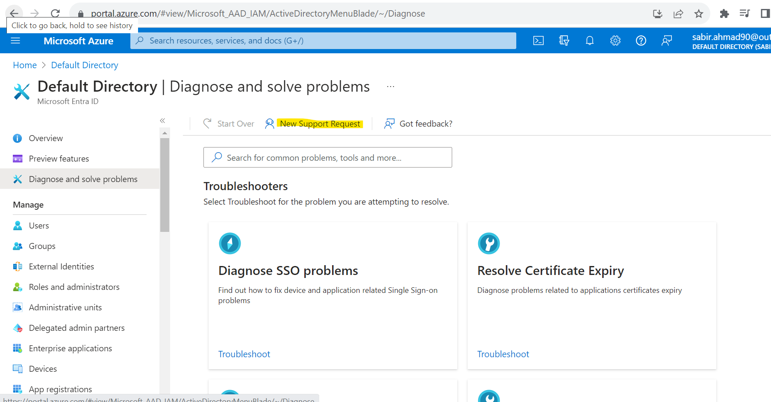

There are multiple options to Diagnose the issue. We also use New Support Request option also but we remember we have opted the no support option while converting our Azure free account to pay-you-go. This service available only for paid option only. We can use this for like normal account issue or based on the services available for free support.

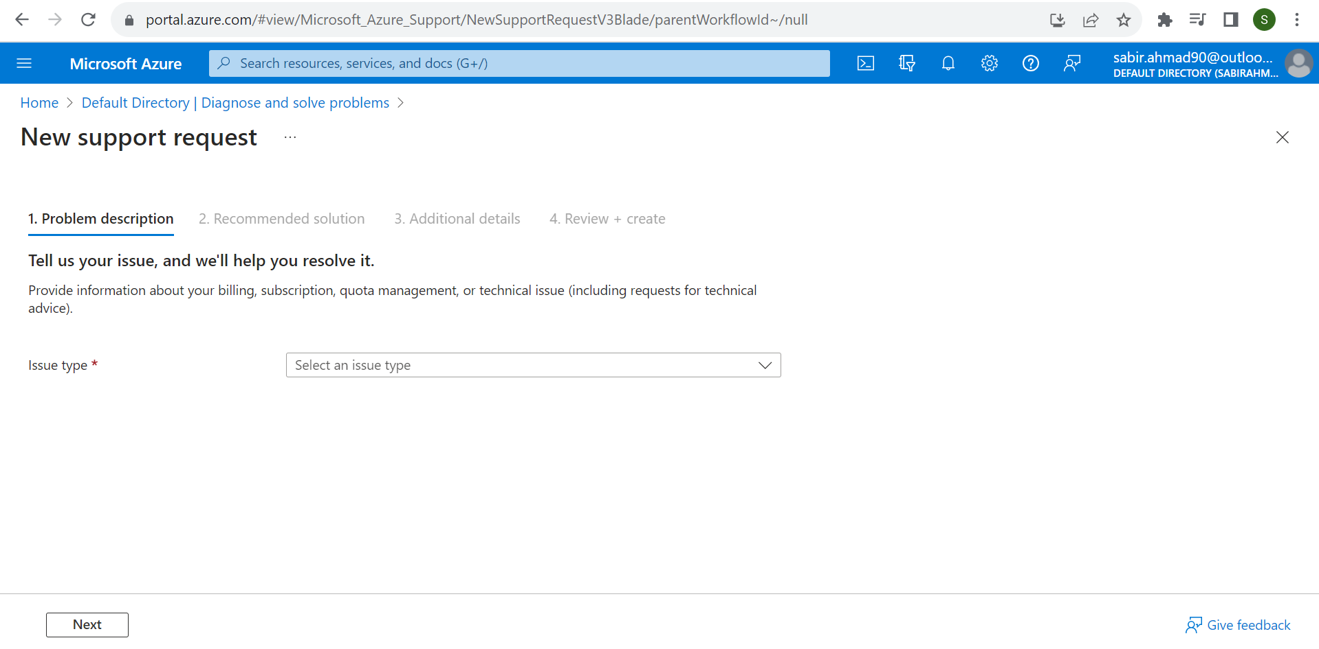

1. Users

Onclick on user option, you get list of users created by you and one default user we can also see the there name, user principle name something like that email id, if the user is from on-premise then the On-Premises sync enabled is Yes otherwise it is No.

We multiple options here New User, Download Users, Bulk operations, Refresh, Manage View, Delete and per-user MFA

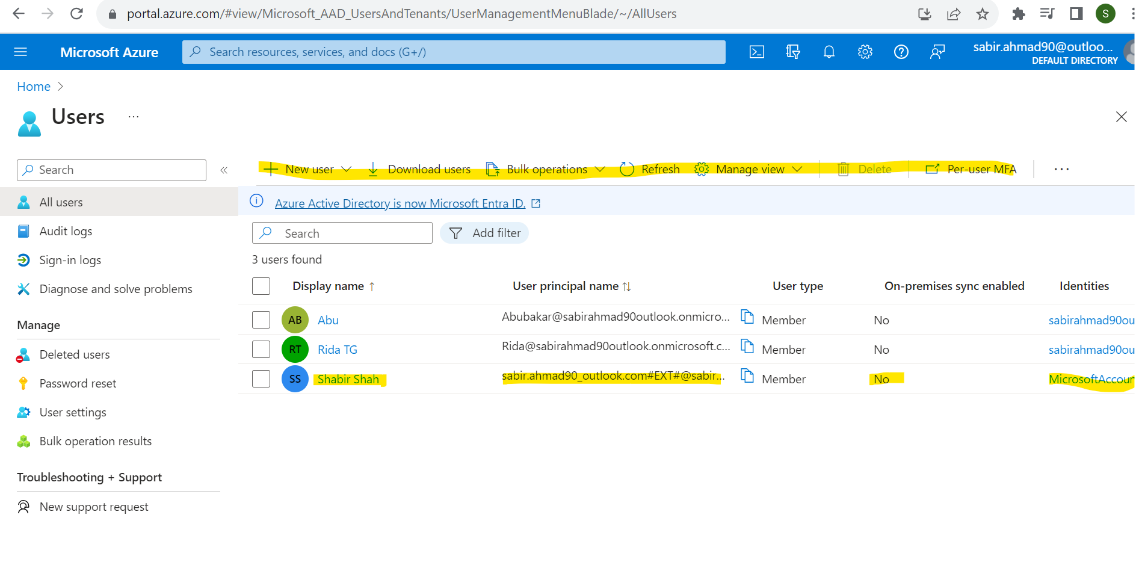

1. New User

Once click on New User option we get the two option here Create New User(internal User) and Invite external user(If we want to add user from different domain or directory we can do ).

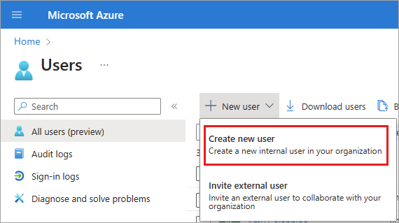

Select **New user** > **Create new user** or **Invite external user**.

1. On the **New User** page, provide the new user's information:
   * **Basics:** Add a user principal name and display name for the user. **User principal name** and **Display name** are required and can't contain accent characters. You can also add a first and last name.

The domain part of the user name must use either the initial default domain name like, yourdomainname.onmicrosoft.com, or a custom domain name, such as contoso.com. For more information about how to create a custom domain name, see [Add your custom domain name](https://learn.microsoft.com/en-us/entra/fundamentals/add-custom-domain).

* + **Assignments** Optionally add the user to one or more existing groups, administrative units, or roles.
  + **Properties**: Add information like the user's usage location, job title, department, company name, and manager. These details can be updated at any time. For more information about adding other user info, see [How to manage user profile information](https://learn.microsoft.com/en-us/entra/fundamentals/how-to-manage-user-profile-info).

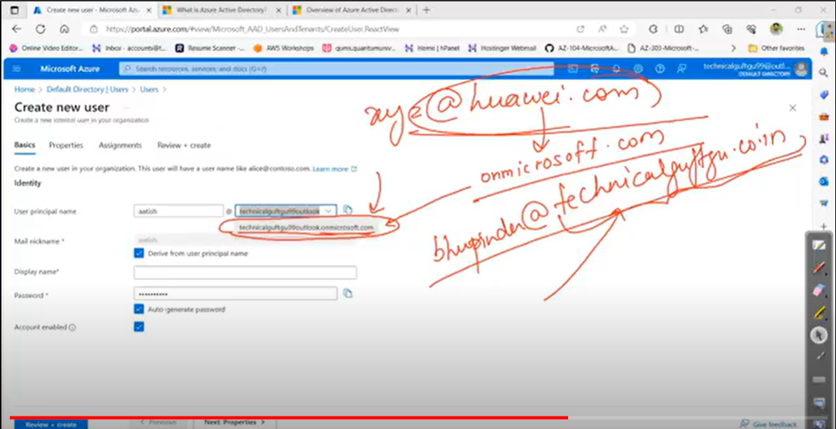

1. Copy the autogenerated password provided in the **Password** box. You need to give this password to the user to sign in for the first time. Or we can set password ourself
2. Check the ckeckbox account Enabled. If we did check checkbox then user can not able to login to the account.
3. Select **Review + create** > **Create**.

Once user created, you see the user in all user list. ,click on user name which you have created from all user list

Click on the user which we created recently, here we can see the User principle name, Object ID, Created date, User type etc.

Copy the User principle name and try to login meanwhile it will asking to make account more secure by using Microsoft authentication app will see next class.

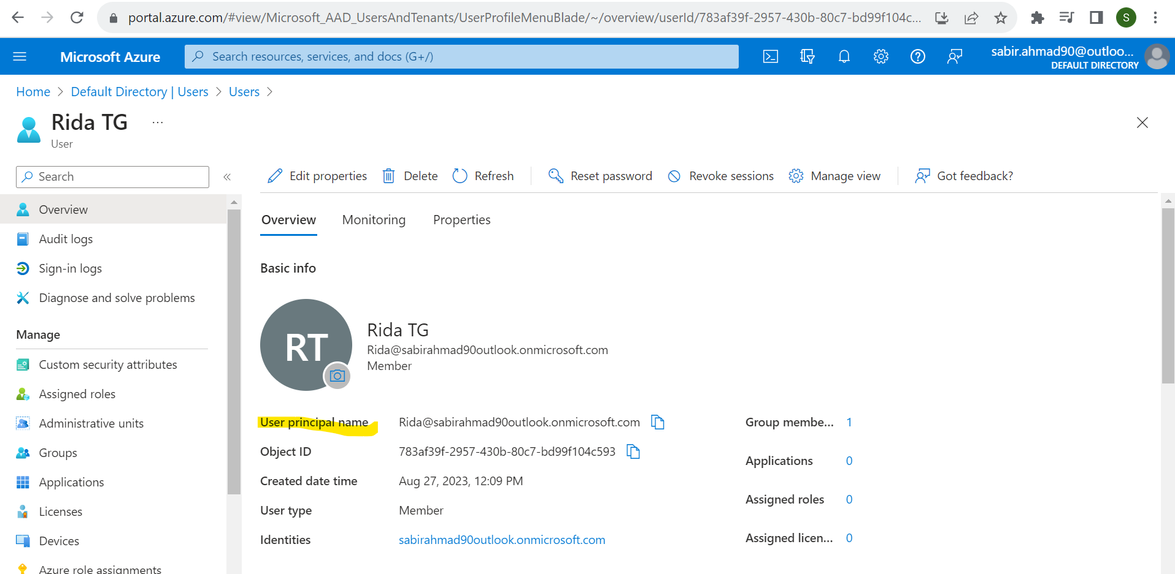

Once you logged-in with this user, check what we can do with this use like create storage account create user , delete user. See He can not create storage account, create user , delete user, can not create VM as well, you see list user and can download user.

# Download a list of users in Azure portal

Microsoft Entra ID, part of Microsoft Entra, supports bulk user list download operations.

## Required permissions

Both admin and non-admin users can download user lists.

## To download a list of users

**Tip**

Steps in this article may vary slightly based on the portal you start from.

1. Sign in to the [Microsoft Entra admin center](https://entra.microsoft.com/) as at least a [Global Administrator](https://learn.microsoft.com/en-us/entra/identity/role-based-access-control/permissions-reference#global-administrator).
2. Select Microsoft Entra ID.
3. Select **Users** > **All users** > **Download users**. By default, all user profiles are exported.
4. On the **Download users** page, select **Start** to receive a CSV file listing user profile properties. If there are errors, you can download and view the results file on the **Bulk operation results** page. The file contains the reason for each error.

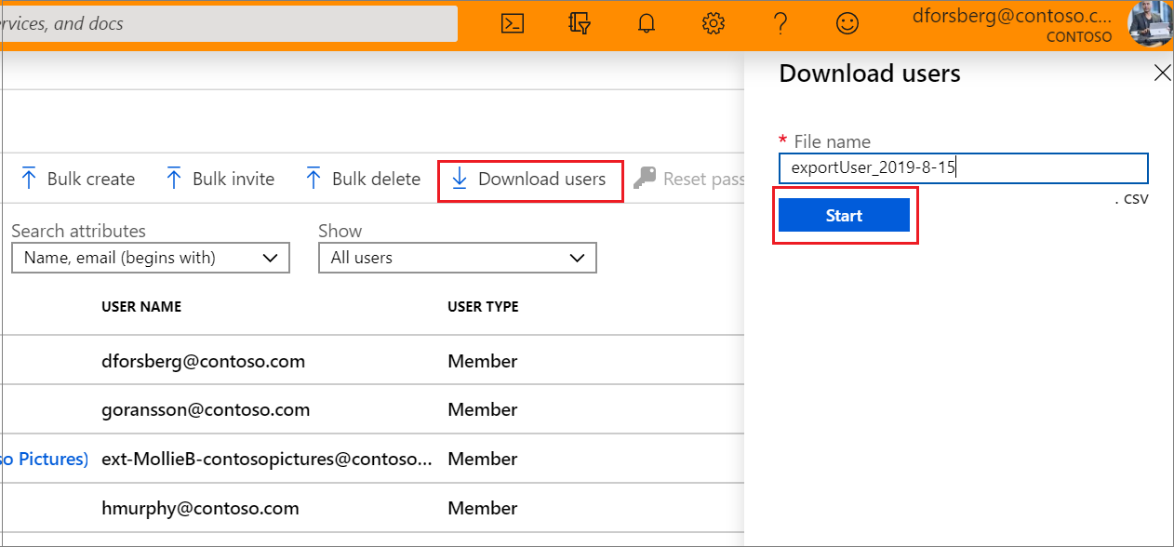

**Note**

The download file will contain the filtered list of users based on the scope of the filters applied.

The following user attributes are included:

* userPrincipalName
* displayName
* surname
* mail
* givenName
* objectId
* userType
* jobTitle
* department
* accountEnabled
* usageLocation
* streetAddress
* state
* country
* physicalDeliveryOfficeName
* city
* postalCode
* telephoneNumber
* mobile
* authenticationAlternativePhoneNumber
* authenticationEmail
* alternateEmailAddress
* ageGroup
* consentProvidedForMinor
* legalAgeGroupClassification

## Check status

You can see the status of your pending bulk requests in the **Bulk operation results** page.

[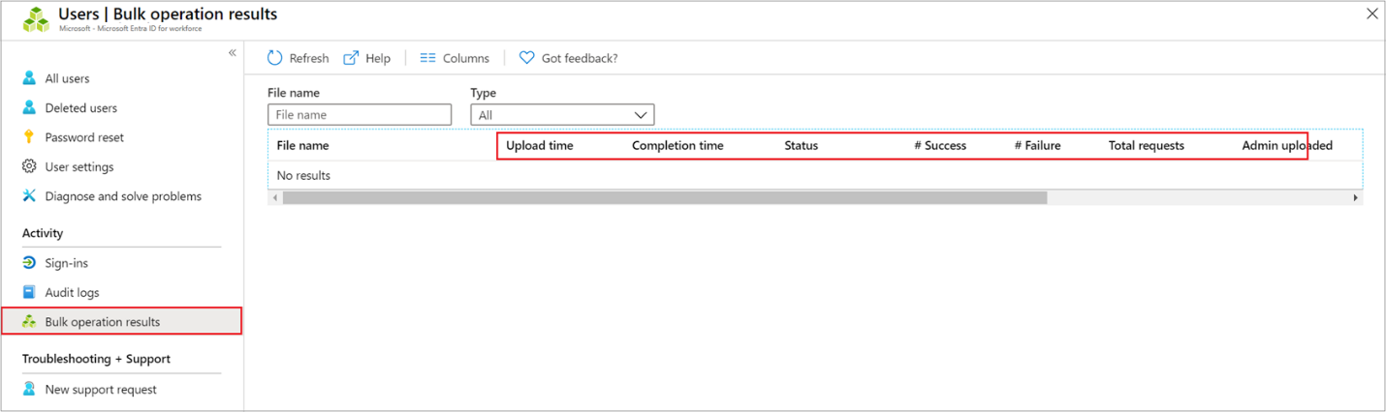](https://learn.microsoft.com/en-us/entra/identity/users/media/users-bulk-download/bulk-center.png#lightbox)

## Bulk download service limits

Each bulk activity to export a list of users can run for up to one hour. This pace enables export and download of a list of up to 500,000 users.

**Note**

When performing bulk operations, such as import or create, you may encounter a problem if the bulk operation does not complete within the hour. To work around this issue, we recommend splitting the number of records processed per batch. For example, before an export, you could limit the result set by filtering on a group type or user name to reduce the size of the results.

If we have requirement to create multiple user like 10 or 100 then you can use the Bulk operation.

# Bulk create users in Microsoft Entra ID

Microsoft Entra ID, part of Microsoft Entra, supports bulk user create and delete operations and supports downloading lists of users. Just fill out comma-separated values (CSV) template you can download from the Azure portal.

## Required permissions

In order to bulk create users in the administration portal, you must be signed in as a Global administrator or User administrator.

## Understand the CSV template

Download and fill in the bulk upload CSV template to help you successfully create Microsoft Entra users in bulk. The CSV template you download might look like this example:

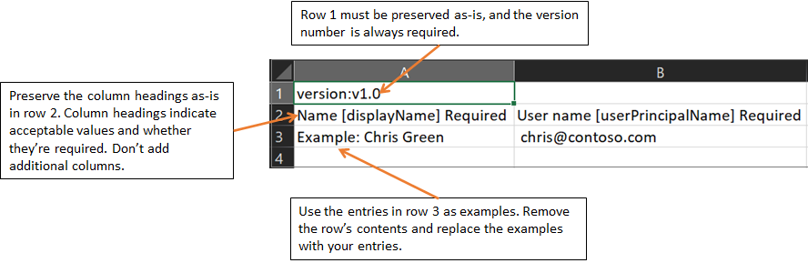

**Warning**

If you are adding only one entry using the CSV template, you must preserve row 3 and add your new entry to row 4.

Ensure that you add the .csv file extension and remove any leading spaces before userPrincipalName, passwordProfile, and accountEnabled.

### CSV template structure

The rows in a downloaded CSV template are as follows:

* **Version number**: The first row containing the version number must be included in the upload CSV.
* **Column headings**: The format of the column headings is <Item name> [PropertyName] <Required or blank>. For example, Name [displayName] Required. Some older versions of the template might have slight variations.
* **Examples row**: We have included in the template a row of examples of acceptable values for each column. You must remove the examples row and replace it with your own entries.

### Additional guidance

* The first two rows of the upload template must not be removed or modified, or the upload can't be processed.
* The required columns are listed first.
* We don't recommend adding new columns to the template. Any additional columns you add are ignored and not processed.
* We recommend that you download the latest version of the CSV template as often as possible.
* Make sure to check there is no unintended whitespace before/after any field. For **User principal name**, having such whitespace would cause import failure.
* Ensure that values in **Initial password** comply with the currently active [password policy](https://learn.microsoft.com/en-us/entra/identity/authentication/concept-sspr-policy#username-policies).

## To create users in bulk

1. Sign in to the [Microsoft Entra admin center](https://entra.microsoft.com/) as at least a [User Administrator](https://learn.microsoft.com/en-us/entra/identity/role-based-access-control/permissions-reference#user-administrator).
2. Select Microsoft Entra ID.
3. Select **All users** > **Users** > **Bulk create**.
4. On the **Bulk create user** page, select **Download** to receive a valid comma-separated values (CSV) file of user properties, and then add users you want to create.

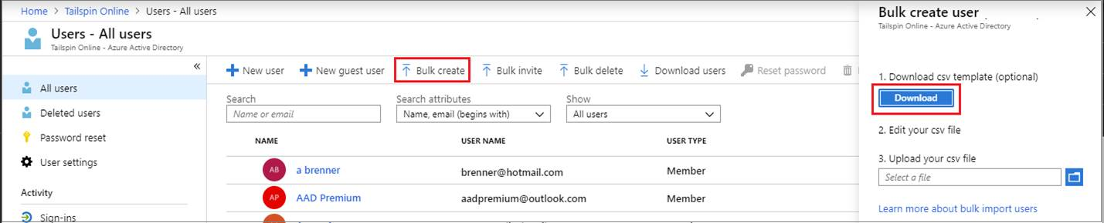

1. Open the CSV file and add a line for each user you want to create. The only required values are **Name**, **User principal name**, **Initial password** and **Block sign in (Yes/No)**. Then save the file.

[](https://learn.microsoft.com/en-us/entra/identity/users/media/users-bulk-add/add-csv-file.png#lightbox)

1. On the **Bulk create user** page, under Upload your CSV file, browse to the file. When you select the file and click **Submit**, validation of the CSV file starts.
2. After the file contents are validated, you’ll see **File uploaded successfully**. If there are errors, you must fix them before you can submit the job.
3. When your file passes validation, select **Submit** to start the Azure bulk operation that imports the new users.
4. When the import operation completes, you'll see a notification of the bulk operation job status.

If there are errors, you can download and view the results file on the **Bulk operation results** page. The file contains the reason for each error. The file submission must match the provided template and include the exact column names.

**Note**

When performing bulk operations, such as import or create, you may encounter a problem if the bulk operation does not complete within the hour. To work around this issue, we recommend splitting the number of records processed per batch. For example, before an export, you could limit the result set by filtering on a group type or user name to reduce the size of the results.

## Check status

You can see the status of all of your pending bulk requests in the **Bulk operation results** page.

[](https://learn.microsoft.com/en-us/entra/identity/users/media/users-bulk-add/bulk-center.png#lightbox)

Next, you can check to see that the users you created exist in the Microsoft Entra organization either in the Azure portal or by using PowerShell.

## Verify users in the Azure portal

1. Sign in to the [Microsoft Entra admin center](https://entra.microsoft.com/) as at least a [User Administrator](https://learn.microsoft.com/en-us/entra/identity/role-based-access-control/permissions-reference#user-administrator).
2. Select Microsoft Entra ID.
3. Select **All users** > **Users**.
4. Under **Show**, select **All users** and verify that the users you created are listed.

### Verify users with PowerShell

Run the following command:

PowerShellCopy

Get-MgUser -Filter "UserType eq 'Member'"

You should see that the users that you created are listed.

## Bulk import service limits

Each bulk activity to create users can run for up to one hour. This enables bulk creation of at least 50,000 users.

## To bulk delete users

**Tip**

Steps in this article may vary slightly based on the portal you start from.

1. Sign in to the [Microsoft Entra admin center](https://entra.microsoft.com/) as at least a [Global Administrator](https://learn.microsoft.com/en-us/entra/identity/role-based-access-control/permissions-reference#global-administrator).
2. Select Microsoft Entra ID.
3. Select **Users** > **All users** > **Bulk operations** > **Bulk delete**.

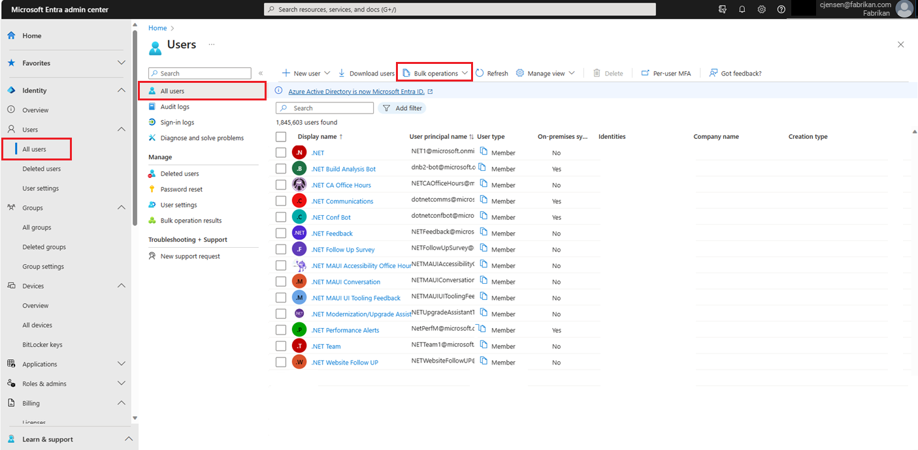

1. On the **Bulk delete user** page, select **Download** to download the latest version of the CSV template.
2. Open the CSV file and add a line for each user you want to delete. The only required value is **User principal name**. Save the file.
3. On the **Bulk delete user** page, under **Upload your csv file**, browse to the file. When you select the file and click submit, validation of the CSV file starts.
4. When the file contents are validated, you’ll see **File uploaded successfully**. If there are errors, you must fix them before you can submit the job.
5. When your file passes validation, select **Submit** to start the bulk operation that deletes the users.
6. When the deletion operation completes, you'll see a notification that the bulk operation succeeded.

If there are errors, you can download and view the results file on the **Bulk operation results** page. The file contains the reason for each error.

**Note**

When performing bulk operations, such as import or create, you may encounter a problem if the bulk operation does not complete within the hour. To work around this issue, we recommend splitting the number of records processed per batch. For example, before an export, you could limit the result set by filtering on a group type or user name to reduce the size of the results.

**CSV template structure**

The rows in the example downloaded CSV template below are as follows:

* **Version number**: The first row containing the version number must be included in the upload CSV.
* **Column headings**: User name [userPrincipalName] Required. Older versions of the template might vary.
* **Examples row**: We have included in the template an example of an acceptable value. Example: chris@contoso.com You must remove the example row and replace it with your own entries

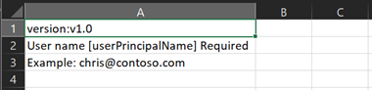

### Additional guidance for the CSV template

* The first two rows of the template must not be removed or modified, or the template can't be processed.
* The required columns are listed first.
* Don't add new columns to the template. Any additional columns you add are ignored and not processed.
* Download the latest version of the CSV template before making new changes.

## Check status

You can see the status of all of your pending bulk requests in the **Bulk operation results** page.



Next, you can check to see that the users you deleted exist in the Microsoft Entra organization either in the portal or by using PowerShell.

## Verify deleted users

1. Sign in to the [Microsoft Entra admin center](https://entra.microsoft.com/) as at least a [User Administrator](https://learn.microsoft.com/en-us/entra/identity/role-based-access-control/permissions-reference#user-administrator).
2. Select Microsoft Entra ID.
3. Select **All users** only and verify that the users you deleted are no longer listed.

### Verify deleted users with PowerShell

Run the following command:

PowerShellCopy

Get-MgUser -Filter "UserType eq 'Member'"

Verify that the users that you deleted are no longer listed.

# Bulk restore deleted users in Microsoft Entra ID

Microsoft Entra ID, part of Microsoft Entra, supports bulk user restore operations and supports downloading lists of users, groups, and group members.

## Understand the CSV template

Download and fill in the CSV template to help you successfully restore Microsoft Entra users in bulk. The CSV template you download might look like this example:

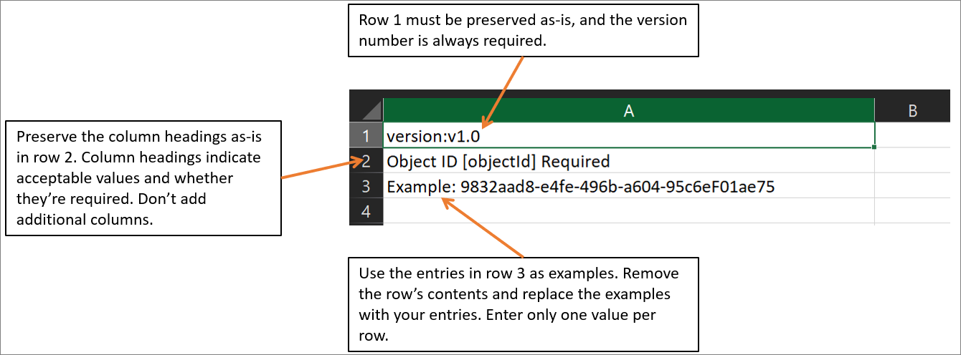

### CSV template structure

The rows in a downloaded CSV template are as follows:

* **Version number**: The first row containing the version number must be included in the upload CSV.
* **Column headings**: The format of the column headings is <Item name> [PropertyName] <Required or blank>. For example, Object ID [objectId] Required. Some older versions of the template might have slight variations.
* **Examples row**: We have included in the template a row of examples of acceptable values for each column. You must remove the examples row and replace it with your own entries.

### Additional guidance

* The first two rows of the upload template must not be removed or modified, or the upload can't be processed.
* The required columns are listed first.
* We don't recommend adding new columns to the template. Any additional columns you add are ignored and not processed.
* We recommend that you download the latest version of the CSV template as often as possible.

## To bulk restore users

**Tip**

Steps in this article may vary slightly based on the portal you start from.

1. Sign in to the [Microsoft Entra admin center](https://entra.microsoft.com/) as at least a [User Administrator](https://learn.microsoft.com/en-us/entra/identity/role-based-access-control/permissions-reference#user-administrator).
2. Select Microsoft Entra ID.
3. Select **All users** > **Users** > **Deleted**.
4. On the **Deleted users** page, select **Bulk restore** to upload a valid CSV file of properties of the users to restore.

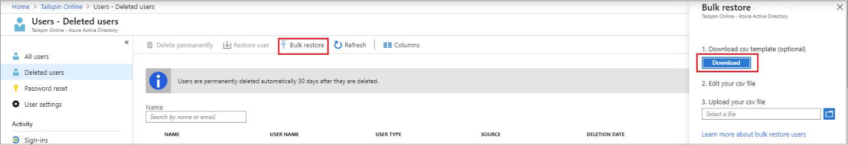

1. Open the CSV template and add a line for each user you want to restore. The only required value is **ObjectID**. Then save the file.

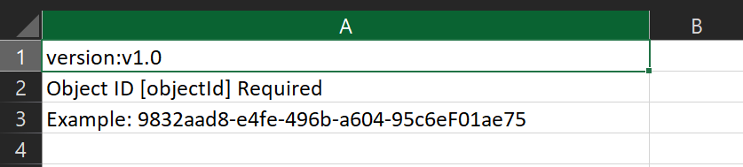

1. On the **Bulk restore** page, under **Upload your csv file**, browse to the file. When you select the file and click **Submit**, validation of the CSV file starts.
2. When the file contents are validated, you’ll see **File uploaded successfully**. If there are errors, you must fix them before you can submit the job.
3. When your file passes validation, select **Submit** to start the Azure bulk operation that restores the users.
4. When the restore operation completes, you'll see a notification that the bulk operation succeeded.

If there are errors, you can download and view the results file on the **Bulk operation results** page. The file contains the reason for each error.

**Note**

When performing bulk operations, such as import or create, you may encounter a problem if the bulk operation does not complete within the hour. To work around this issue, we recommend splitting the number of records processed per batch. For example, before an export, you could limit the result set by filtering on a group type or user name to reduce the size of the results.

## Check status

You can see the status of all of your pending bulk requests in the **Bulk operation results** page.

[](https://learn.microsoft.com/en-us/entra/identity/users/media/users-bulk-restore/bulk-center.png#lightbox)

Next, you can check to see that the users you restored exist in the Microsoft Entra organization via either the Azure portal or PowerShell.

## View restored users in the Azure portal

1. Sign in to the [Microsoft Entra admin center](https://entra.microsoft.com/) as at least a [User Administrator](https://learn.microsoft.com/en-us/entra/identity/role-based-access-control/permissions-reference#user-administrator).
2. Select Microsoft Entra ID.
3. Select **All users** Under **Manage**, select **Users**.
4. Under **Show**, select **All users** and verify that the users you restored are listed.

### View users with PowerShell

Run the following command:

PowerShellCopy

Get-MgUser -Filter "UserType eq 'Member'"

You should see that the users that you restored are listed.

## Add a new guest user

You can also invite new guest user to collaborate with your organization by selecting **Invite external user** from the **New user** page. If your organization's external collaboration settings are configured to allow guests, the user will be emailed an invitation they must accept in order to begin collaborating. For more information about inviting B2B collaboration users, see [Invite B2B users to Microsoft Entra ID](https://learn.microsoft.com/en-us/entra/external-id/add-users-administrator).

The process for inviting a guest is the same as [adding a new user](https://learn.microsoft.com/en-us/entra/fundamentals/add-users#add-a-new-user), with two exceptions. The email address won't follow the same domain rules as users from your organization. You can also include a personal message

## Add other users

There might be scenarios in which you want to manually create consumer accounts in your Azure Active Directory B2C (Azure AD B2C) directory. For more information about creating consumer accounts, see [Create and delete consumer users in Azure AD B2C](https://learn.microsoft.com/en-us/azure/active-directory-b2c/manage-users-portal).

If you have an environment with both Microsoft Entra ID (cloud) and Windows Server Active Directory (on-premises), you can add new users by syncing the existing user account data. For more information about hybrid environments and users, see [Integrate your on-premises directories with Microsoft Entra ID](https://learn.microsoft.com/en-us/entra/identity/hybrid/whatis-hybrid-identity).

## Delete a user

You can delete an existing user using Microsoft Entra admin center.

* You must have a Global Administrator, Privileged Authentication Administrator or User Administrator role assignment to delete users in your organization.
* Global Admins and Privileged Authentication Admins can delete any users including other admins.
* User Administrators can delete any non-admin users, Helpdesk Administrators and other User Administrators.
* For more information, see [Administrator role permissions](https://learn.microsoft.com/en-us/entra/identity/role-based-access-control/permissions-reference).

To delete a user, follow these steps:

1. Sign in to the [Microsoft Entra admin center](https://entra.microsoft.com/) as at least a [User Administrator](https://learn.microsoft.com/en-us/entra/identity/role-based-access-control/permissions-reference#user-administrator).
2. Browse to **Identity** > **Users** > **All users**.
3. Search for and select the user you want to delete.
4. Select **Delete**.

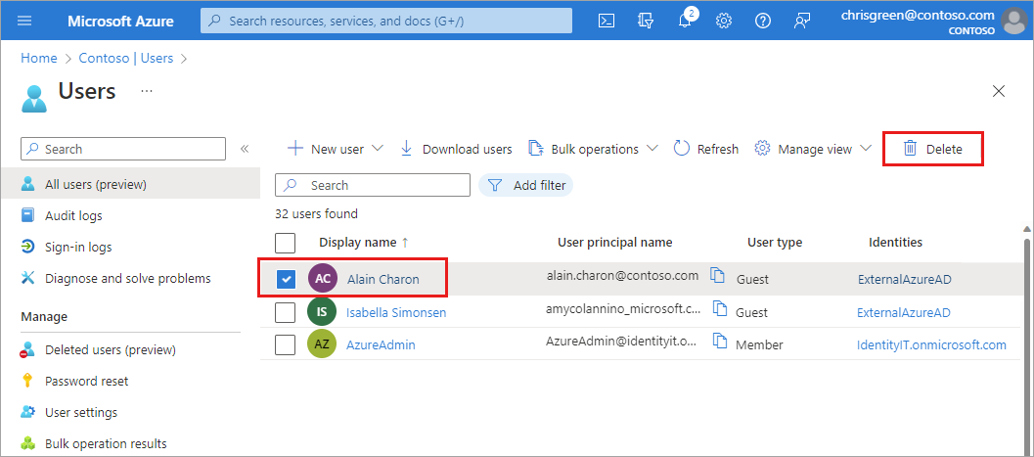

The user is deleted and no longer appears on the **All users** page. The user can be seen on the **Deleted users** page for the next 30 days and can be restored during that time. For more information about restoring a user, see [Restore or remove a recently deleted user](https://learn.microsoft.com/en-us/entra/fundamentals/users-restore).

When a user is deleted, any licenses consumed by the user are made available for other users.

**Note**

To update the identity, contact information, or job information for users whose source of authority is Windows Server Active Directory, you must use Windows Server Active Directory. After you complete the update, you must wait for the next synchronization cycle to complete before you'll see the changes.

# Restore or remove a recently deleted user

After you delete a user, the account remains in a suspended state for 30 days. During that 30-day window, the user account can be restored, along with all its properties.

After that 30-day window passes, the permanent deletion process is automatically started and can't be stopped. During this time, the management of soft-deleted users is blocked. This limitation also applies to restoring a soft-deleted user via a match during Tenant sync cycle for on-premises hybrid scenarios.

You can view your restorable users, restore a deleted user, or permanently delete a user using the Microsoft Entra admin center.

**Important**

Neither you nor Microsoft customer support can restore a permanently deleted user.

## Required permissions

You must have one of the following roles to restore and permanently delete users.

* Global Administrator
* Partner Tier1 Support
* Partner Tier2 Support
* User Administrator

## View your restorable users

You can see all the users that were deleted less than 30 days ago. These users can be restored.

### To view your restorable users

**Tip**

Steps in this article may vary slightly based on the portal you start from.

1. Sign in to the [Microsoft Entra admin center](https://entra.microsoft.com/) as at least a [User Administrator](https://learn.microsoft.com/en-us/entra/identity/role-based-access-control/permissions-reference#user-administrator).
2. Browse to **Identity** > **Users** > **Deleted users**.

Review the list of users that are available to restore.

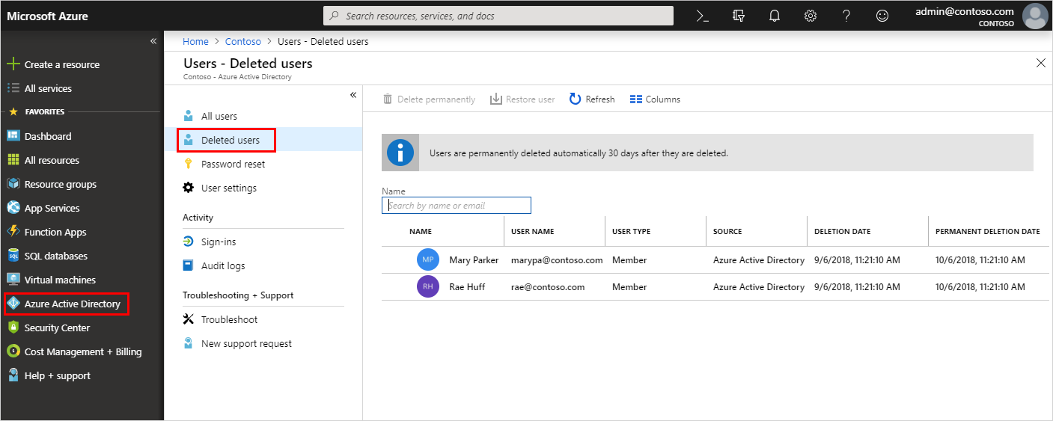

## Restore a recently deleted user

When a user account is deleted from the organization, the account is in a suspended state. All of the account's organization information is preserved. When you restore a user, this organization information is also restored.

**Note**

Once a user is restored, licenses that were assigned to the user at the time of deletion are also restored even if there are no seats available for those licenses. If you are then consuming more licenses more than you purchased, your organization could be temporarily out of compliance for license usage.

### To restore a user

1. On the **Deleted users** page, search for and select one of the available users. For example, Mary Parker.
2. Select **Restore user**.

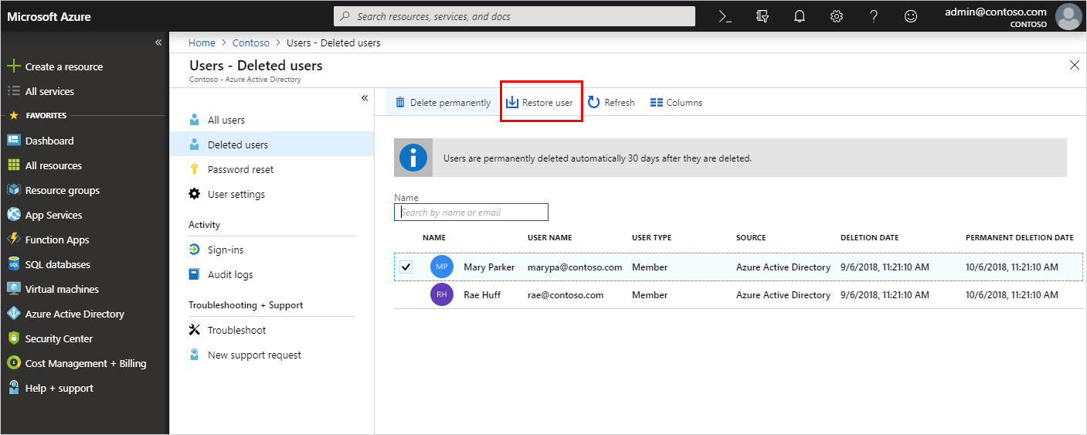

## Permanently delete a user

You can permanently delete a user from your organization without waiting the 30 days for automatic deletion. A permanently deleted user can't be restored by you, another administrator, nor by Microsoft customer support.

**Note**

If you permanently delete a user by mistake, you'll have to create a new user and manually enter all the previous information. For more information about creating a new user, see [**Add or delete users**](https://learn.microsoft.com/en-us/entra/fundamentals/add-users).

### To permanently delete a user

1. On the **Deleted users** page, search for and select one of the available users. For example, Rae Huff.
2. Select **Delete permanently**.

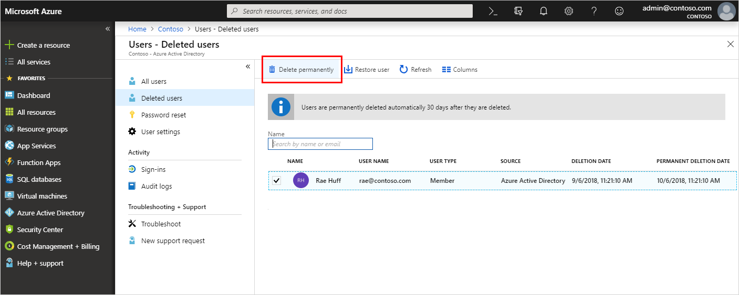

**Manage View:**

If we want to show column or hide the column like Display name, User principal name etc. on the UI or we can change the order of the column. We make this by using the Manage View option.

Manage View => Edit column

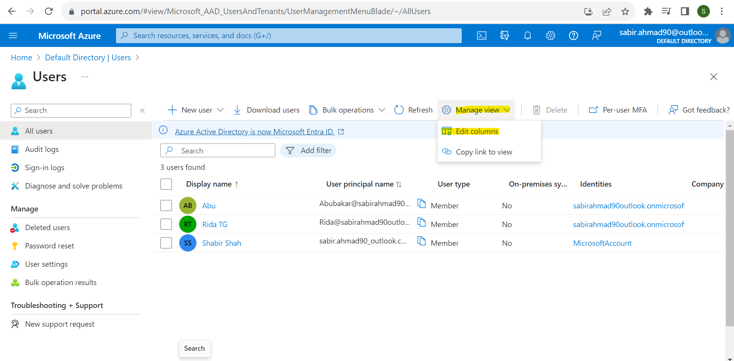

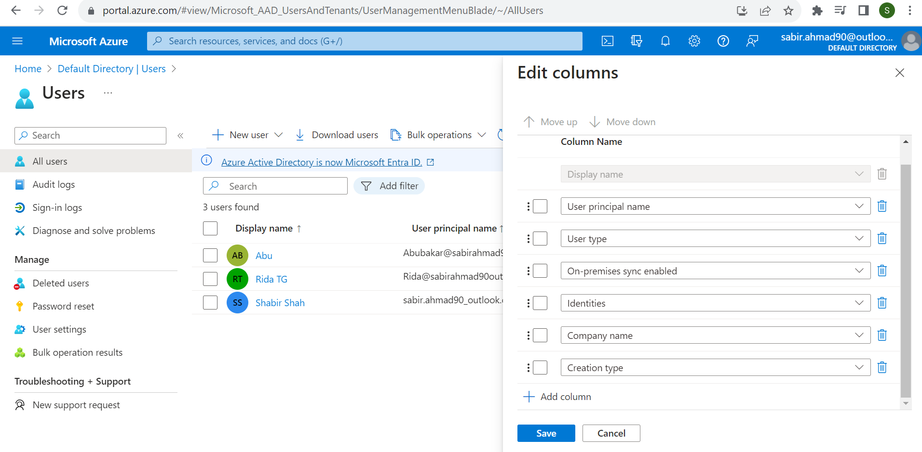

# Reset a user's password

Administrators can reset a user's password if the password is forgotten, if the user gets locked out of a device, or if the user never received a password.

**Note**

If you're not an administrator and you need instructions on how to reset your own work or school password, see [**Reset your work or school password**](https://support.microsoft.com/account-billing/reset-your-work-or-school-password-using-security-info-23dde81f-08bb-4776-ba72-e6b72b9dda9e).

Unless your tenant is the home directory for a user, you won't be able reset their password. This means that if your user is signing in to your organization using an account from another organization, a Microsoft account, or a Google account, you won't be able to reset their password.

If your user has a source of authority as Windows Server Active Directory, you'll only be able to reset the password if you've turned on password writeback and the user domain is managed. Changing the user password for federated domains is not supported. In this case, you should change the user password in the on-premises Active Directory.

If your user has a source of authority as External Microsoft Entra ID, you won't be able to reset the password. Only the user, or an administrator in that tenant, can reset the password.

## To reset a password

## <https://learn.microsoft.com/en-us/entra/fundamentals/users-reset-password-azure-portal>

**Tip**

Steps in this article may vary slightly based on the portal you start from.

1. Sign in to the [Microsoft Entra admin center](https://entra.microsoft.com/) as at least a [Password Administrator](https://learn.microsoft.com/en-us/entra/identity/role-based-access-control/permissions-reference#password-administrator).
2. Browse to **Identity** > **Users** > **All users**.
3. Select the user that needs the reset, then select **Reset Password**.

The **Alain Charon - Profile** page appears with the **Reset password** option.

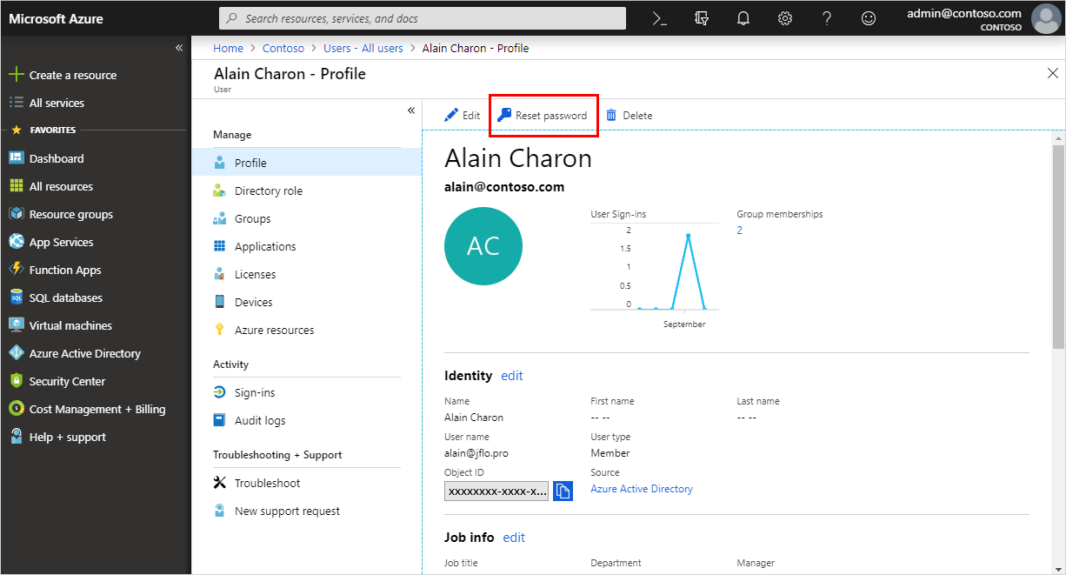

1. In the **Reset password** page, select **Reset password**.

**Note**

When using Microsoft Entra ID, a temporary password is auto-generated for the user. When using Active Directory on-premises, you create the password for the user.

1. Copy the password and give it to the user. The user will be required to change the password during the next sign-in process.
2. 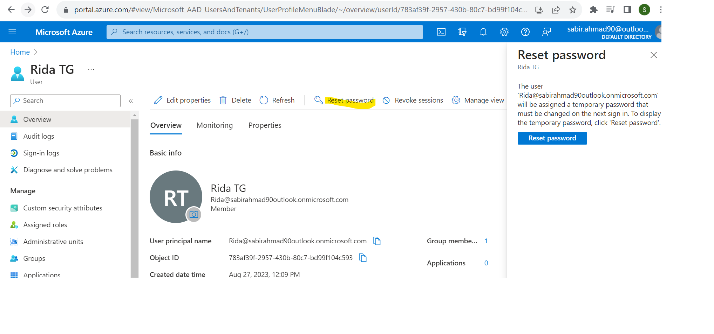

**Note**

The temporary password never expires. The next time the user signs in, the password will still work, regardless how much time has passed since the temporary password was generated.

**Important**

If an administrator is unable to reset the user's password, and the Application Event Logs on the Microsoft Entra Connect server has error code hr=80231367, review the user's attributes in Active Directory. If the attribute **AdminCount** is set to 1, this will prevent an administrator from resetting the user's password. The attribute **AdminCount** must be set to 0, in order for an administrators to reset the user's password.

# Add or update a user's profile information and settings

<https://learn.microsoft.com/en-us/entra/fundamentals/how-to-manage-user-profile-info>

A user's profile information and settings can be managed on an individual basis and for all users in your directory. When you look at these settings together, you can see how permissions, restrictions, and other connections work together.

This article covers how to add user profile information, such as a profile picture and job-specific information. You can also choose to allow users to connect their LinkedIn accounts or restrict access to the Microsoft Entra administration portal. Some settings may be managed in more than one area. For more information about adding new users, see [How to add or delete users in Microsoft Entra ID](https://learn.microsoft.com/en-us/entra/fundamentals/add-users).

## Add or change profile information

**Tip**

Steps in this article may vary slightly based on the portal you start from.

When new users are created, only a few details are added to their user profile. If your organization needs more details, they can be added after the user is created.

1. Sign in to the [Microsoft Entra admin center](https://entra.microsoft.com/) as at least a [User Administrator](https://learn.microsoft.com/en-us/entra/identity/role-based-access-control/permissions-reference#user-administrator).
2. Browse to **Identity** > **Users** > **All users**.
3. Select a user.
4. There are two ways to edit user profile details. Either select **Edit properties** from the top of the page or select **Properties**.

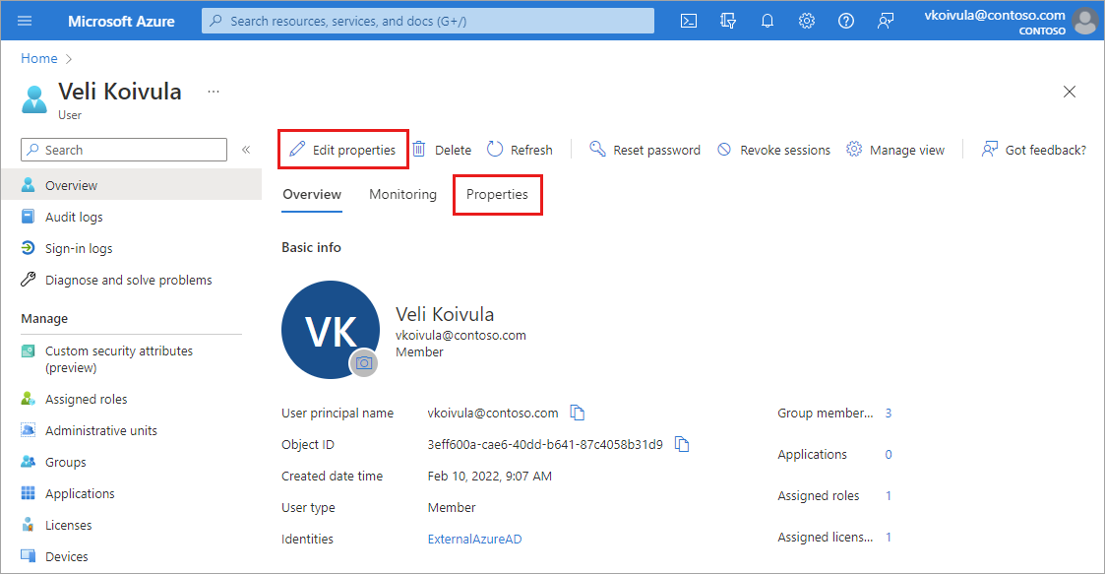

1. After making any changes, select the **Save** button.

If you selected the **Edit properties** option:

* The full list of properties appears in edit mode on the **All** category.
* To edit properties based on the category, select a category from the top of the page.
* Select the **Save** button at the bottom of the page to save any changes.

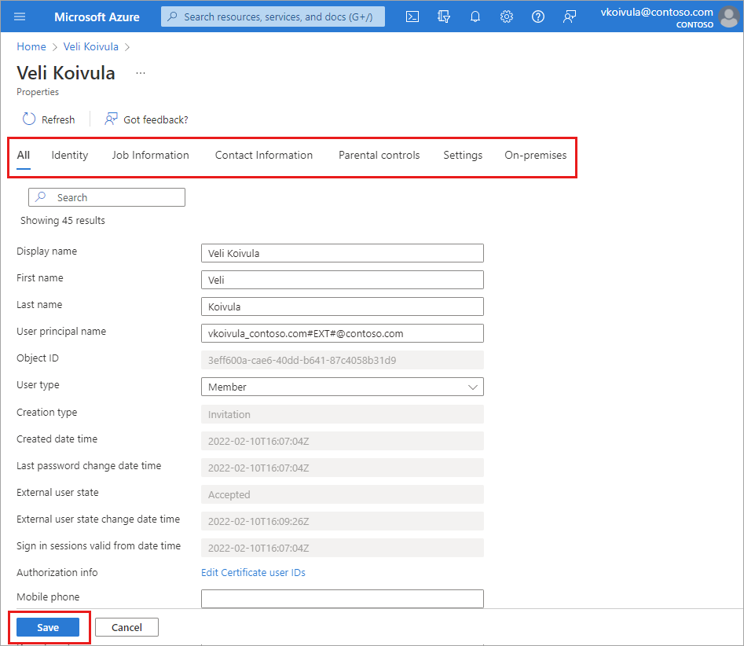

If you selected the **Properties** tab option:

* The full list of properties appears for you to review.
* To edit a property, select the pencil icon next to the category heading.
* Select the **Save** button at the bottom of the page to save any changes.

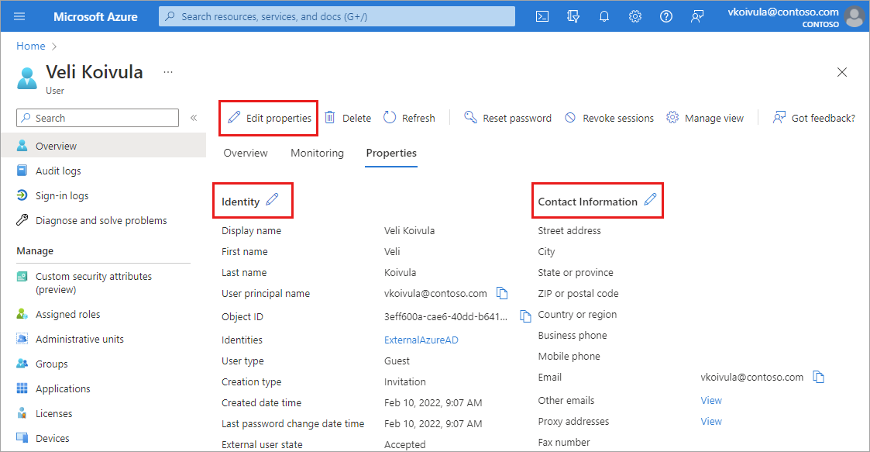

### Profile categories

There are six categories of profile details you may be able to edit.

* **Identity:** Add or update other identity values for the user, such as a married last name. You can set this name independently from the values of First name and Last name. For example, you could use it to include initials, a company name, or to change the sequence of names shown. If you have two users with the same name, such as ‘Chris Green,’ you could use the Identity string to set their names to 'Chris B. Green' and 'Chris R. Green.'
* **Job information:** Add any job-related information, such as the user's job title, department, or manager.
* **Contact info:** Add any relevant contact information for the user.
* **Parental controls:** For organizations like K-12 school districts, the user's age group may need to be provided. Minors are 12 and under, Not adult are 13-18 years old, and Adults are 18 and over. The combination of age group and consent provided by parent options determine the Legal age group classification. The Legal age group classification may limit the user's access and authority.
* **Settings:** Decide whether the user can sign in to the Microsoft Entra tenant. You can also specify the user's global location.
* **On-premises:** Accounts synced from Windows Server Active Directory include other values not applicable to Microsoft Entra accounts.

**Note**

You must use Windows Server Active Directory to update the identity, contact info, or job info for users whose source of authority is Windows Server Active Directory. After you complete your update, you must wait for the next synchronization cycle to complete before you'll see the changes.

### Add or edit the profile picture

On the user's overview page, select the camera icon in the lower-right corner of the user's thumbnail. If no image has been added, the user's initials appear here. This picture appears in Microsoft Entra ID and on the user's personal pages, such as the myapps.microsoft.com page.

All your changes are saved for the user.

**Note**

If you're having issues updating a user's profile picture, please ensure that your Office 365 Exchange Online Enterprise App is Enabled for users to sign in.

## Manage settings for all users

In the **User settings** area, you can adjust several settings that affect all users. Some settings are managed in a separate area linked from this page. These settings require the Global Administrator role.

1. Sign in to the [Microsoft Entra admin center](https://entra.microsoft.com/) as a [Global Administrator](https://learn.microsoft.com/en-us/entra/identity/role-based-access-control/permissions-reference#global-administrator).
2. Browse to **Identity** > **Users** > **User settings**.

[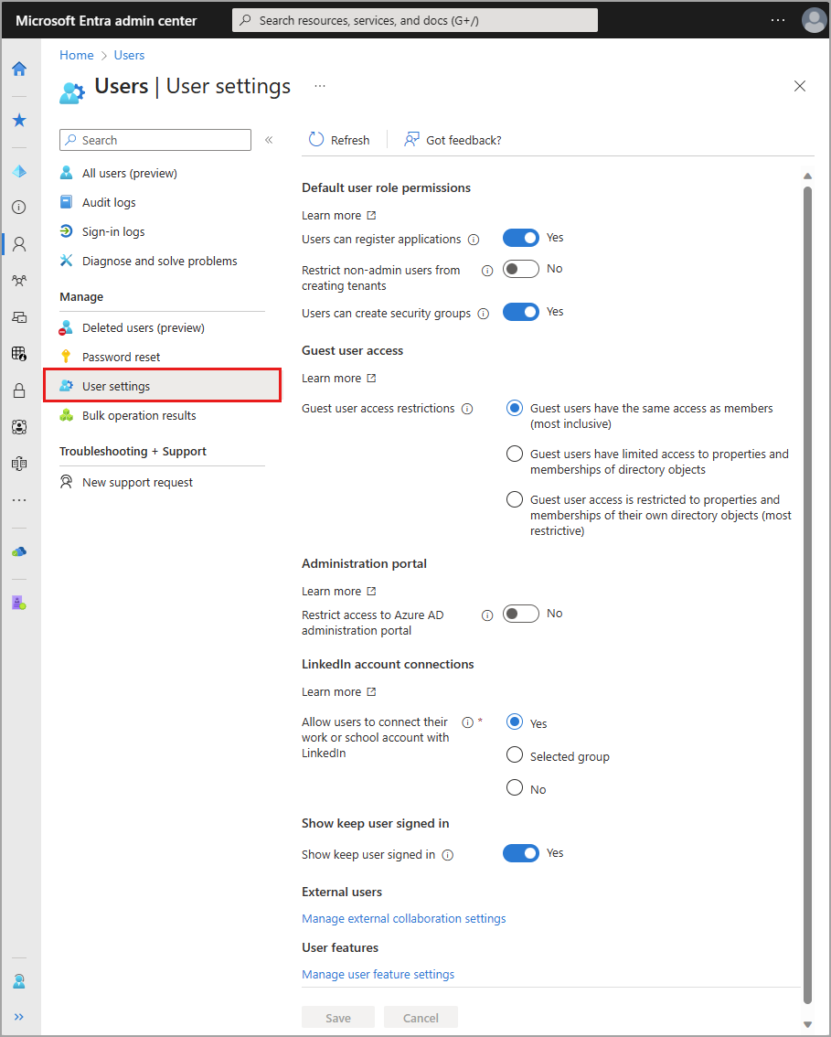](https://learn.microsoft.com/en-us/entra/fundamentals/media/how-to-manage-user-profile-info/user-settings.png#lightbox)

The following settings can be managed from **User settings**.

* Allow users to register their own applications
* Prevent non-admins from creating their own tenants
  + For more information, see [default user permissions](https://learn.microsoft.com/en-us/entra/fundamentals/users-default-permissions#restrict-member-users-default-permissions)
* Allow users to create security groups
* Guest user access restrictions
  + Guest users have the same access as members (most inclusive)
  + Guest users have limited access to properties and memberships of directory objects
  + Guest user access is restricted to properties and memberships of their own directory objects (most restrictive)
* Restrict access to the Microsoft Entra administration portal
* [Allow users to connect their work or school account with LinkedIn](https://learn.microsoft.com/en-us/entra/identity/users/linkedin-user-consent)
* [Enable the "Stay signed in?" prompt](https://learn.microsoft.com/en-us/entra/fundamentals/how-to-manage-stay-signed-in-prompt)
* Manage external collaboration settings
  + [Guest user access](https://learn.microsoft.com/en-us/entra/identity/users/users-restrict-guest-permissions)
  + [Guest invite setting](https://learn.microsoft.com/en-us/entra/external-id/external-collaboration-settings-configure)
  + [External user leave settings](https://learn.microsoft.com/en-us/entra/external-id/self-service-sign-up-user-flow#enable-self-service-sign-up-for-your-tenant)
  + Collaboration restrictions
* Manage user feature settings
  + Users can use preview features for My Apps
  + Administrators can access My Staff

# What are the default user permissions in Microsoft Entra ID?

<https://learn.microsoft.com/en-us/entra/fundamentals/users-default-permissions>

In Microsoft Entra ID, all users are granted a set of default permissions. A user's access consists of the type of user, their [role assignments](https://learn.microsoft.com/en-us/entra/fundamentals/how-subscriptions-associated-directory), and their ownership of individual objects.

This article describes those default permissions and compares the member and guest user defaults. The default user permissions can be changed only in user settings in Microsoft Entra ID.

## Member and guest users

The set of default permissions depends on whether the user is a native member of the tenant (member user) or whether the user is brought over from another directory as a business-to-business (B2B) collaboration guest (guest user). For more information about adding guest users, see [What is Microsoft Entra B2B collaboration?](https://learn.microsoft.com/en-us/entra/external-id/what-is-b2b). Here are the capabilities of the default permissions:

* Member users can register applications, manage their own profile photo and mobile phone number, change their own password, and invite B2B guests. These users can also read all directory information (with a few exceptions).
* Guest users have restricted directory permissions. They can manage their own profile, change their own password, and retrieve some information about other users, groups, and apps. However, they can't read all directory information.

For example, guest users can't enumerate the list of all users, groups, and other directory objects. Guests can be added to administrator roles, which grant them full read and write permissions. Guests can also invite other guests.

## Compare member and guest default permissions

| **Area** | **Member user permissions** | **Default guest user permissions** | **Restricted guest user permissions** |
| --- | --- | --- | --- |
| Users and contacts | * Enumerate the list of all users and contacts * Read all public properties of users and contacts * Invite guests * Change their own password * Manage their own mobile phone number * Manage their own photo * Invalidate their own refresh tokens | * Read their own properties * Read display name, email, sign-in name, photo, user principal name, and user type properties of other users and contacts * Change their own password * Search for another user by object ID (if allowed) * Read manager and direct report information of other users | * Read their own properties * Change their own password * Manage their own mobile phone number |
| Groups | * Create security groups * Create Microsoft 365 groups * Enumerate the list of all groups * Read all properties of groups * Read non-hidden group memberships * Read hidden Microsoft 365 group memberships for joined groups * Manage properties, ownership, and membership of groups that the user owns * Add guests to owned groups * Manage dynamic membership settings * Delete owned groups * Restore owned Microsoft 365 groups | * Read properties of non-hidden groups, including membership and ownership (even non-joined groups) * Read hidden Microsoft 365 group memberships for joined groups * Search for groups by display name or object ID (if allowed) | * Read object ID for joined groups * Read membership and ownership of joined groups in some Microsoft 365 apps (if allowed) |
| Applications | * Register (create) new applications * Enumerate the list of all applications * Read properties of registered and enterprise applications * Manage application properties, assignments, and credentials for owned applications * Create or delete application passwords for users * Delete owned applications * Restore owned applications * List permissions granted to applications | * Read properties of registered and enterprise applications * List permissions granted to applications | * Read properties of registered and enterprise applications * List permissions granted to applications |
| Devices | * Enumerate the list of all devices * Read all properties of devices * Manage all properties of owned devices | No permissions | No permissions |
| Organization | * Read all company information * Read all domains * Read configuration of certificate-based authentication * Read all partner contracts * Read multi-tenant organization basic details and active tenants | * Read company display name * Read all domains * Read configuration of certificate-based authentication | * Read company display name * Read all domains |
| Roles and scopes | * Read all administrative roles and memberships * Read all properties and membership of administrative units | No permissions | No permissions |
| Subscriptions | * Read all licensing subscriptions * Enable service plan memberships | No permissions | No permissions |
| Policies | * Read all properties of policies * Manage all properties of owned policies | No permissions | No permissions |

## Restrict member users' default permissions

It's possible to add restrictions to users' default permissions.

You can restrict default permissions for member users in the following ways:

**Caution**

Using the **Restrict access to Microsoft Entra administration portal** switch **is NOT a security measure**. For more information on the functionality, see the table below.

| **Permission** | **Setting explanation** |
| --- | --- |
| **Register applications** | Setting this option to **No** prevents users from creating application registrations. You can then grant the ability back to specific individuals, by adding them to the application developer role. |
| **Allow users to connect work or school account with LinkedIn** | Setting this option to **No** prevents users from connecting their work or school account with their LinkedIn account. For more information, see [LinkedIn account connections data sharing and consent](https://learn.microsoft.com/en-us/entra/identity/users/linkedin-user-consent). |
| **Create security groups** | Setting this option to **No** prevents users from creating security groups. Global Administrators and User Administrators can still create security groups. To learn how, see [Microsoft Entra cmdlets for configuring group settings](https://learn.microsoft.com/en-us/entra/identity/users/groups-settings-cmdlets). |
| **Create Microsoft 365 groups** | Setting this option to **No** prevents users from creating Microsoft 365 groups. Setting this option to **Some** allows a set of users to create Microsoft 365 groups. Global Administrators and User Administrators can still create Microsoft 365 groups. To learn how, see [Microsoft Entra cmdlets for configuring group settings](https://learn.microsoft.com/en-us/entra/identity/users/groups-settings-cmdlets). |
| **Restrict access to Microsoft Entra administration portal** | **What does this switch do?** **No** lets non-administrators browse the Microsoft Entra administration portal. **Yes** Restricts non-administrators from browsing the Microsoft Entra administration portal. Non-administrators who are owners of groups or applications are unable to use the Azure portal to manage their owned resources.  **What does it not do?** It doesn't restrict access to Microsoft Entra data using PowerShell, Microsoft GraphAPI, or other clients such as Visual Studio. It doesn't restrict access as long as a user is assigned a custom role (or any role).  **When should I use this switch?** Use this option to prevent users from misconfiguring the resources that they own.  **When should I not use this switch?** Don't use this switch as a security measure. Instead, create a Conditional Access policy that targets Microsoft Azure Management that blocks non-administrators access to [Microsoft Azure Management](https://learn.microsoft.com/en-us/entra/identity/conditional-access/concept-conditional-access-cloud-apps#microsoft-azure-management).  **How do I grant only a specific non-administrator users the ability to use the Microsoft Entra administration portal?** Set this option to **Yes**, then assign them a role like global reader.  **Restrict access to the Microsoft Entra administration portal** A Conditional Access policy that targets Microsoft Azure Management targets access to all Azure management. |
| **Restrict non-admin users from creating tenants** | Users can create tenants in the Microsoft Entra ID and Microsoft Entra administration portal under Manage tenant. The creation of a tenant is recorded in the Audit log as category DirectoryManagement and activity Create Company. Anyone who creates a tenant becomes the Global Administrator of that tenant. The newly created tenant doesn't inherit any settings or configurations.  **What does this switch do?** Setting this option to **Yes** restricts creation of Microsoft Entra tenants to the Global Administrator or tenant creator roles. Setting this option to **No** allows non-admin users to create Microsoft Entra tenants. Tenant create will continue to be recorded in the Audit log.  **How do I grant only a specific non-administrator users the ability to create new tenants?** Set this option to Yes, then assign them the tenant creator role. |
| **Restrict users from recovering the BitLocker key(s) for their owned devices** | This setting can be found in the Microsoft Entra admin center in the Device Settings. Setting this option to **Yes** restricts users from being able to self-service recover BitLocker key(s) for their owned devices. Users will have to contact their organization's helpdesk to retrieve their BitLocker keys. Setting this option to **No** allows users to recover their BitLocker key(s). |
| **Read other users** | This setting is available in Microsoft Graph and PowerShell only. Setting this flag to $false prevents all non-admins from reading user information from the directory. This flag doesn't prevent reading user information in other Microsoft services like Exchange Online.  This setting is meant for special circumstances, so we don't recommend setting the flag to $false. |

The **Restrict non-admin users from creating tenants** option is shown [below](https://portal.azure.com/#view/Microsoft_AAD_IAM/ActiveDirectoryMenuBlade/%7E/UserSettings)

[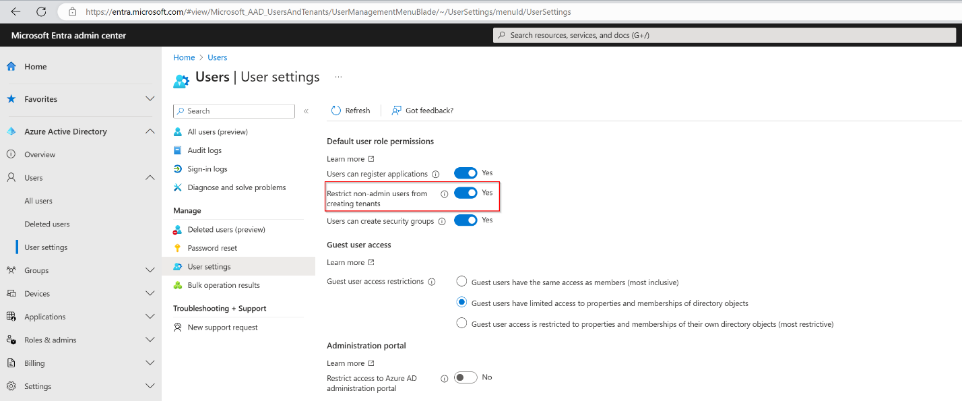](https://learn.microsoft.com/en-us/entra/fundamentals/media/user-default-permissions/tenant-creation-restriction.png#lightbox)

## Restrict guest users' default permissions

You can restrict default permissions for guest users in the following ways.

**Note**

The **Guest user access restrictions** setting replaced the **Guest users permissions are limited** setting. For guidance on using this feature, see [**Restrict guest access permissions in Microsoft Entra ID**](https://learn.microsoft.com/en-us/entra/identity/users/users-restrict-guest-permissions).

| **Permission** | **Setting explanation** |
| --- | --- |
| **Guest user access restrictions** | Setting this option to **Guest users have the same access as members** grants all member user permissions to guest users by default.  Setting this option to **Guest user access is restricted to properties and memberships of their own directory objects** restricts guest access to only their own user profile by default. Access to other users is no longer allowed, even when they're searching by user principal name, object ID, or display name. Access to group information, including groups memberships, is also no longer allowed.  This setting doesn't prevent access to joined groups in some Microsoft 365 services like Microsoft Teams. To learn more, see [Microsoft Teams guest access](https://learn.microsoft.com/en-us/MicrosoftTeams/guest-access).  Guest users can still be added to administrator roles regardless of this permission setting. |
| **Guests can invite** | Setting this option to **Yes** allows guests to invite other guests. To learn more, see [Configure external collaboration settings](https://learn.microsoft.com/en-us/entra/external-id/external-collaboration-settings-configure). |

## Object ownership

### Application registration owner permissions

When a user registers an application, they're automatically added as an owner for the application. As an owner, they can manage the metadata of the application, such as the name and permissions that the app requests. They can also manage the tenant-specific configuration of the application, such as the single sign-on (SSO) configuration and user assignments.

An owner can also add or remove other owners. Unlike Global Administrators, owners can manage only the applications that they own.

### Enterprise application owner permissions

When a user adds a new enterprise application, they're automatically added as an owner. As an owner, they can manage the tenant-specific configuration of the application, such as the SSO configuration, provisioning, and user assignments.

An owner can also add or remove other owners. Unlike Global Administrators, owners can manage only the applications that they own.

### Group owner permissions

When a user creates a group, they're automatically added as an owner for that group. As an owner, they can manage properties of the group (such as the name) and manage group membership.

An owner can also add or remove other owners. Unlike Global Administrators and User Administrators, owners can manage only the groups that they own.

To assign a group owner, see [Managing owners for a group](https://learn.microsoft.com/en-us/entra/fundamentals/how-to-manage-groups).

### Ownership permissions

The following tables describe the specific permissions in Microsoft Entra ID that member users have over owned objects. Users have these permissions only on objects that they own.

#### Owned application registrations

Users can perform the following actions on owned application registrations:

| **Action** | **Description** |
| --- | --- |
| microsoft.directory/applications/audience/update | Update the applications.audience property in Microsoft Entra ID. |
| microsoft.directory/applications/authentication/update | Update the applications.authentication property in Microsoft Entra ID. |
| microsoft.directory/applications/basic/update | Update basic properties on applications in Microsoft Entra ID. |
| microsoft.directory/applications/credentials/update | Update the applications.credentials property in Microsoft Entra ID. |
| microsoft.directory/applications/delete | Delete applications in Microsoft Entra ID. |
| microsoft.directory/applications/owners/update | Update the applications.owners property in Microsoft Entra ID. |
| microsoft.directory/applications/permissions/update | Update the applications.permissions property in Microsoft Entra ID. |
| microsoft.directory/applications/policies/update | Update the applications.policies property in Microsoft Entra ID. |
| microsoft.directory/applications/restore | Restore applications in Microsoft Entra ID. |

#### Owned enterprise applications

Users can perform the following actions on owned enterprise applications. An enterprise application consists of a service principal, one or more application policies, and sometimes an application object in the same tenant as the service principal.

| **Action** | **Description** |
| --- | --- |
| microsoft.directory/auditLogs/allProperties/read | Read all properties (including privileged properties) on audit logs in Microsoft Entra ID. |
| microsoft.directory/policies/basic/update | Update basic properties on policies in Microsoft Entra ID. |
| microsoft.directory/policies/delete | Delete policies in Microsoft Entra ID. |
| microsoft.directory/policies/owners/update | Update the policies.owners property in Microsoft Entra ID. |
| microsoft.directory/servicePrincipals/appRoleAssignedTo/update | Update the servicePrincipals.appRoleAssignedTo property in Microsoft Entra ID. |
| microsoft.directory/servicePrincipals/appRoleAssignments/update | Update the users.appRoleAssignments property in Microsoft Entra ID. |
| microsoft.directory/servicePrincipals/audience/update | Update the servicePrincipals.audience property in Microsoft Entra ID. |
| microsoft.directory/servicePrincipals/authentication/update | Update the servicePrincipals.authentication property in Microsoft Entra ID. |
| microsoft.directory/servicePrincipals/basic/update | Update basic properties on service principals in Microsoft Entra ID. |
| microsoft.directory/servicePrincipals/credentials/update | Update the servicePrincipals.credentials property in Microsoft Entra ID. |
| microsoft.directory/servicePrincipals/delete | Delete service principals in Microsoft Entra ID. |
| microsoft.directory/servicePrincipals/owners/update | Update the servicePrincipals.owners property in Microsoft Entra ID. |
| microsoft.directory/servicePrincipals/permissions/update | Update the servicePrincipals.permissions property in Microsoft Entra ID. |
| microsoft.directory/servicePrincipals/policies/update | Update the servicePrincipals.policies property in Microsoft Entra ID. |
| microsoft.directory/signInReports/allProperties/read | Read all properties (including privileged properties) on sign-in reports in Microsoft Entra ID. |
| microsoft.directory/servicePrincipals/synchronizationCredentials/manage | Manage application provisioning secrets and credentials |
| microsoft.directory/servicePrincipals/synchronizationJobs/manage | Start, restart, and pause application provisioning synchronization jobs |
| microsoft.directory/servicePrincipals/synchronizationSchema/manage | Create and manage application provisioning synchronization jobs and schema |
| microsoft.directory/servicePrincipals/synchronization/standard/read | Read provisioning settings associated with your service principal |

#### Owned devices

Users can perform the following actions on owned devices:

| **Action** | **Description** |
| --- | --- |
| microsoft.directory/devices/bitLockerRecoveryKeys/read | Read the devices.bitLockerRecoveryKeys property in Microsoft Entra ID. |
| microsoft.directory/devices/disable | Disable devices in Microsoft Entra ID. |

#### Owned groups

Users can perform the following actions on owned groups.

**Note**

Owners of dynamic groups must have a Global Administrator, Group Administrator, Intune Administrator, or User Administrator role to edit group membership rules. For more information, see [**Create or update a dynamic group in Microsoft Entra ID**](https://learn.microsoft.com/en-us/entra/identity/users/groups-create-rule).

| **Action** | **Description** |
| --- | --- |
| microsoft.directory/groups/appRoleAssignments/update | Update the groups.appRoleAssignments property in Microsoft Entra ID. |
| microsoft.directory/groups/basic/update | Update basic properties on groups in Microsoft Entra ID. |
| microsoft.directory/groups/delete | Delete groups in Microsoft Entra ID. |
| microsoft.directory/groups/members/update | Update the groups.members property in Microsoft Entra ID. |
| microsoft.directory/groups/owners/update | Update the groups.owners property in Microsoft Entra ID. |
| microsoft.directory/groups/restore | Restore groups in Microsoft Entra ID. |
| microsoft.directory/groups/settings/update | Update the groups.settings property in Microsoft Entra ID. |

# Manage the 'Stay signed in?' prompt

<https://learn.microsoft.com/en-us/entra/fundamentals/how-to-manage-stay-signed-in-prompt>

The **Stay signed in?** prompt appears after a user successfully signs in. This process is known as **Keep me signed in** (KMSI) and was previously part of the [customize branding](https://learn.microsoft.com/en-us/entra/fundamentals/how-to-customize-branding) process.

This article covers how the KMSI process works, how to enable it for customers, and how to troubleshoot KMSI issues.

## How does it work?

If a user answers **Yes** to the **'Stay signed in?'** prompt, a persistent authentication cookie is issued. The cookie must be stored in session for KMSI to work. KMSI doesn't work with locally stored cookies. If KMSI isn't enabled, a non-persistent cookie is issued and lasts for 24 hours or until the browser is closed.

The following diagram shows the user sign-in flow for a managed tenant and federated tenant using the KMSI in prompt. This flow contains smart logic so that the **Stay signed in?** option isn't displayed if the machine learning system detects a high-risk sign-in or a sign-in from a shared device. For federated tenants, the prompt will show after the user successfully authenticates with the federated identity service.

Some features of SharePoint Online and Office 2010 depend on users being able to choose to remain signed in. If you uncheck the **Show option to remain signed in** option, your users may see other unexpected prompts during the sign-in process.

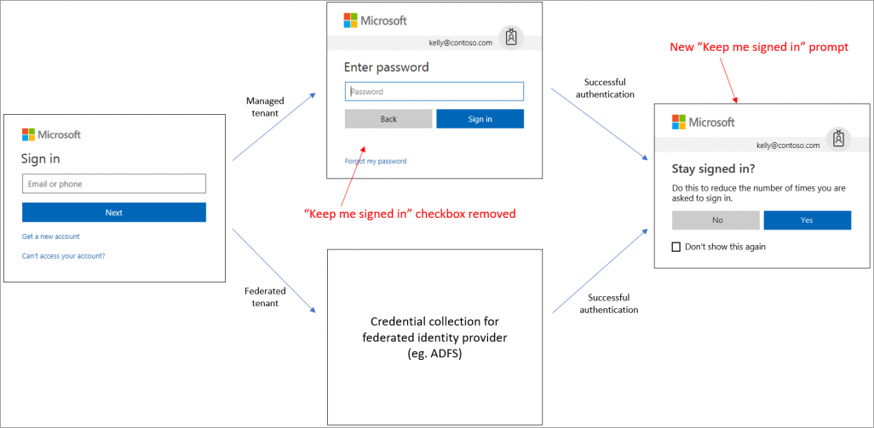

## License and role requirements

Configuring the 'keep me signed in' (KMSI) option requires one of the following licenses:

* Microsoft Entra ID P1 or P2
* Office 365 (for Office apps)
* Microsoft 365

You must have the **Global Administrator** role to enable the 'Stay signed in?' prompt.

## Enable the 'Stay signed in?' prompt

**Tip**

Steps in this article may vary slightly based on the portal you start from.

The KMSI setting is managed in **User settings**.

1. Sign in to the [Microsoft Entra admin center](https://entra.microsoft.com/) as a [Global Administrator](https://learn.microsoft.com/en-us/entra/identity/role-based-access-control/permissions-reference#global-administrator).
2. Browse to **Identity** > **Users** > **User settings**.
3. Set the **Show keep user signed in** toggle to **Yes**.

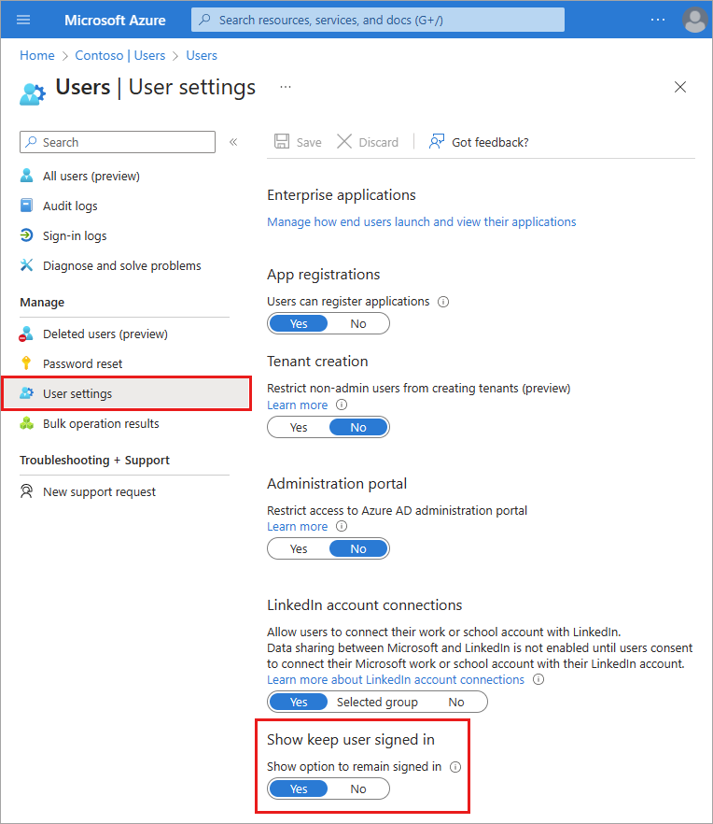

## Troubleshoot 'Stay signed in?' issues

If a user doesn't act on the **Stay signed in?** prompt but abandons the sign-in attempt, a sign-in log entry appears in the Microsoft Entra sign-in logs. The prompt the user sees is called an "interrupt."

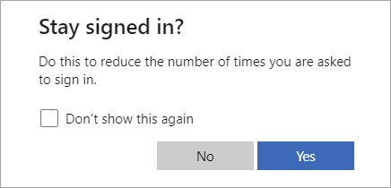

Details about the sign-in error are found in the **Sign-in logs**. Select the impacted user from the list and locate the following details in the **Basic info** section.

* **Sign in error code**: 50140
* **Failure reason**: This error occurred due to "Keep me signed in" interrupt when the user was signing in.

You can stop users from seeing the interrupt by setting the **Show option to remain signed in** setting to **No** in the user settings. This setting disables the KMSI prompt for all users in your directory.

You also can use the [persistent browser session controls in Conditional Access](https://learn.microsoft.com/en-us/entra/identity/conditional-access/howto-conditional-access-session-lifetime) to prevent users from seeing the KMSI prompt. This option allows you to disable the KMSI prompt for a select group of users (such as the Global Administrators) without affecting sign-in behavior for everyone else in the directory.

To ensure that the KMSI prompt is shown only when it can benefit the user, the KMSI prompt is intentionally not shown in the following scenarios:

* User is signed in via seamless SSO and integrated Windows authentication (IWA)
* User is signed in via Active Directory Federation Services and IWA
* User is a guest in the tenant
* User's risk score is high
* Sign-in occurs during user or admin consent flow
* Persistent browser session control is configured in a Conditional Access policy

# How it works: Microsoft Entra self-service password reset

<https://learn.microsoft.com/en-us/entra/identity/authentication/concept-sspr-howitworks>

Microsoft Entra self-service password reset (SSPR) gives users the ability to change or reset their password, with no administrator or help desk involvement. If a user's account is locked or they forget their password, they can follow prompts to unblock themselves and get back to work. This ability reduces help desk calls and loss of productivity when a user can't sign in to their device or an application. We recommend this video on [how to enable and configure SSPR in Microsoft Entra ID](https://www.youtube.com/watch?v=rA8TvhNcCvQ).

**Important**

This conceptual article explains to an administrator how self-service password reset works. If you're an end user already registered for self-service password reset and need to get back into your account, go to [**https://aka.ms/sspr**](https://aka.ms/sspr).

If your IT team hasn't enabled the ability to reset your own password, reach out to your helpdesk for additional assistance.

## How does the password reset process work?

A user can reset or change their password using the [SSPR portal](https://aka.ms/sspr). They must first have registered their desired authentication methods. When a user accesses the SSPR portal, the Azure platform considers the following factors:

* How should the page be localized?
* Is the user account valid?
* What organization does the user belong to?
* Where is the user's password managed?

When a user selects the **Can't access your account** link from an application or page, or goes directly to [https://aka.ms/sspr](https://passwordreset.microsoftonline.com/), the language used in the SSPR portal is based on the following options:

* By default, the browser locale is used to display the SSPR in the appropriate language. The password reset experience is localized into the same languages that [Microsoft 365 supports](https://support.microsoft.com/office/what-languages-is-office-available-in-26d30382-9fba-45dd-bf55-02ab03e2a7ec).
* If you want to link to the SSPR in a specific localized language, append ?mkt= to the end of the password reset URL along with the required locale.
  + For example, to specify the Spanish es-us locale, use ?mkt=es-us - <https://passwordreset.microsoftonline.com/?mkt=es-us>.

After the SSPR portal is displayed in the required language, the user is prompted to enter a user ID and pass a captcha. Microsoft Entra ID now verifies that the user is able to use SSPR by doing the following checks:

* Checks that the user has SSPR enabled.
  + If the user isn't enabled for SSPR, the user is asked to contact their administrator to reset their password.
* Checks that the user has the right authentication methods defined on their account in accordance with administrator policy.
  + If the policy requires only one method, check that the user has the appropriate data defined for at least one of the authentication methods enabled by the administrator policy.
    - If the authentication methods aren't configured, the user is advised to contact their administrator to reset their password.
  + If the policy requires two methods, check that the user has the appropriate data defined for at least two of the authentication methods enabled by the administrator policy.
    - If the authentication methods aren't configured, the user is advised to contact their administrator to reset their password.
  + If an Azure administrator role is assigned to the user, then the strong two-gate password policy is enforced. For more information, see [Administrator reset policy differences](https://learn.microsoft.com/en-us/entra/identity/authentication/concept-sspr-policy#administrator-reset-policy-differences).
* Checks to see if the user's password is managed on-premises, such as if the Microsoft Entra tenant is using federated, pass-through authentication, or password hash synchronization:
  + If SSPR writeback is configured and the user's password is managed on-premises, the user is allowed to proceed to authenticate and reset their password.
  + If SSPR writeback isn't deployed and the user's password is managed on-premises, the user is asked to contact their administrator to reset their password.

If all of the previous checks are successfully completed, the user is guided through the process to reset or change their password.

**Note**

SSPR may send email notifications to users as part of the password reset process. These emails are sent using the SMTP relay service, which operates in an active-active mode across several regions.

SMTP relay services receive and process the email body, but don't store it. The body of the SSPR email that may potentially contain customer provided info isn't stored in the SMTP relay service logs. The logs only contain protocol metadata.

To get started with SSPR, complete the following tutorial:

# Tutorial: Enable users to unlock their account or reset passwords using Microsoft Entra self-service password reset

<https://learn.microsoft.com/en-us/entra/identity/authentication/tutorial-enable-sspr>

Microsoft Entra self-service password reset (SSPR) gives users the ability to change or reset their password, with no administrator or help desk involvement. If Microsoft Entra ID locks a user's account or they forget their password, they can follow prompts to unblock themselves and get back to work. This ability reduces help desk calls and loss of productivity when a user can't sign in to their device or an application. We recommend this video on [How to enable and configure SSPR in Microsoft Entra ID](https://www.youtube.com/watch?v=rA8TvhNcCvQ). We also have a video for IT administrators on [resolving the six most common end-user error messages with SSPR](https://www.youtube.com/watch?v=9RPrNVLzT8I).

**Important**

This tutorial shows an administrator how to enable self-service password reset. If you're an end user already registered for self-service password reset and need to get back into your account, go to the [**Microsoft Online password reset**](https://passwordreset.microsoftonline.com/) page.

If your IT team hasn't enabled the ability to reset your own password, reach out to your helpdesk for additional assistance.

In this tutorial you learn how to:

* Enable self-service password reset for a group of Microsoft Entra users
* Set up authentication methods and registration options
* Test the SSPR process as a user

**Important**

In March 2023, we announced the deprecation of managing authentication methods in the legacy multifactor authentication and self-service password reset (SSPR) policies. Beginning September 30, 2024, authentication methods can't be managed in these legacy MFA and SSPR policies. We recommend customers use the manual migration control to migrate to the Authentication methods policy by the deprecation date.

## Video tutorial

You can also follow along in a related video: [How to enable and configure SSPR in Microsoft Entra ID](https://www.youtube.com/embed/rA8TvhNcCvQ?azure-portal=true).

## Prerequisites

To finish this tutorial, you need the following resources and privileges:

* A working Microsoft Entra tenant with at least a Microsoft Entra ID Free or trial license enabled. In the Free tier, SSPR only works for cloud users in Microsoft Entra ID. Password change is supported in the Free tier, but password reset is not.
  + For later tutorials in this series, you'll need a Microsoft Entra ID P1 or trial license for on-premises password writeback.
  + If needed, [create an Azure account for free](https://azure.microsoft.com/free/?WT.mc_id=A261C142F).
* An account with Global Administrator or Authentication Policy Administrator privileges.
* A non-administrator user with a password you know, like testuser. You'll test the end-user SSPR experience using this account in this tutorial.
  + If you need to create a user, see [Quickstart: Add new users to Microsoft Entra ID](https://learn.microsoft.com/en-us/entra/fundamentals/add-users).
* A group that the non-administrator user is a member of, likes SSPR-Test-Group. You'll enable SSPR for this group in this tutorial.
  + If you need to create a group, see [Create a basic group and add members using Microsoft Entra ID](https://learn.microsoft.com/en-us/entra/fundamentals/how-to-manage-groups).
* We need to enable the Microsoft entre P2 license

# Default Directory =>Password Reser=> Self-Service Password Reset

* 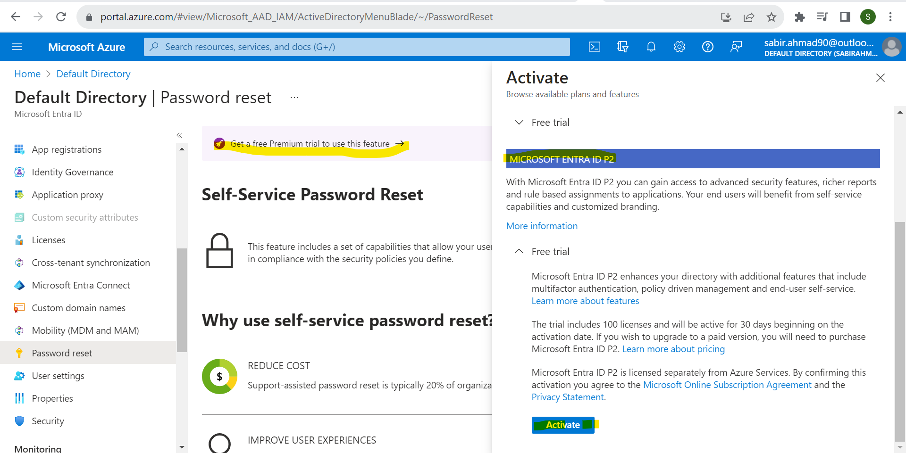
* Once you enable the P2 license.

# We can not reset without enable of SSPR

* To check follow the below process
* 1)click on Forgot my password link
* 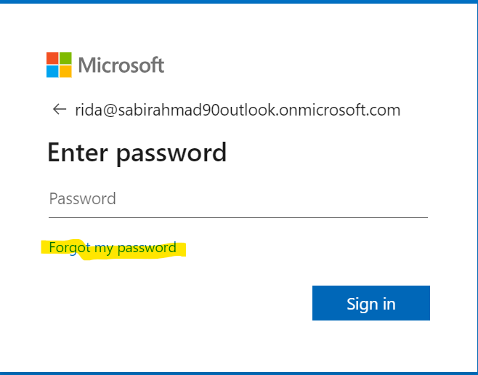
* 2) Enter the CAPCHA and click Next
* 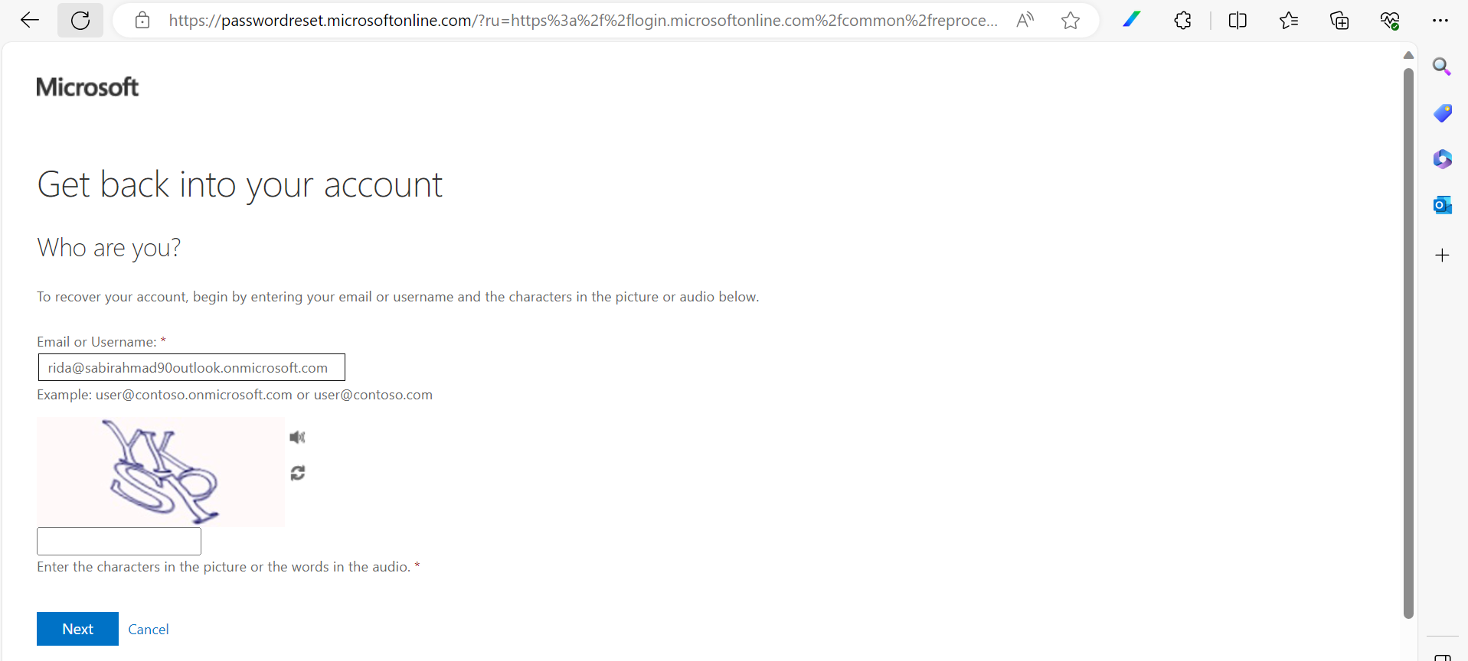
* 3)See we can not reset password here  
  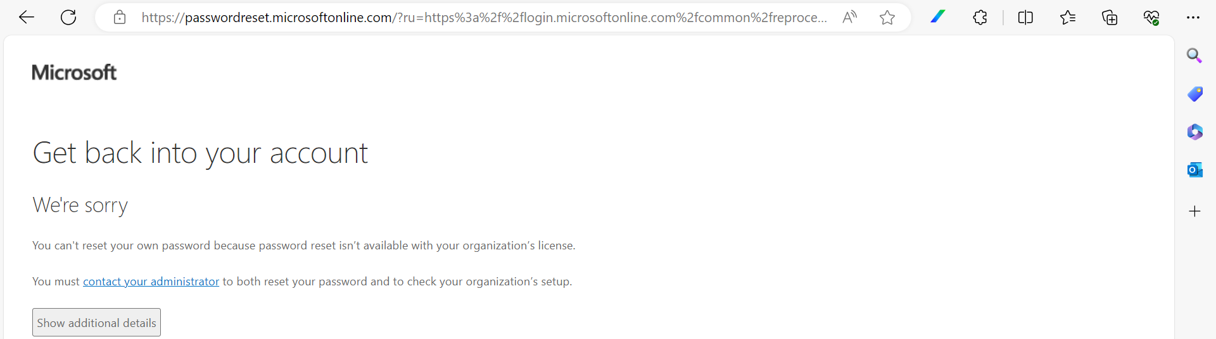

## Enable self-service password reset

**Tip**

Steps in this article may vary slightly based on the portal you start from.

Microsoft Entra ID lets you enable SSPR for None, Selected, or All users. This granular ability lets you choose a subset of users to test the SSPR registration process and workflow. When you're comfortable with the process and the time is right to communicate the requirements with a broader set of users, you can select a group of users to enable for SSPR. Or, you can enable SSPR for everyone in the Microsoft Entra tenant.

**Note**

Currently, you can only enable one Microsoft Entra group for SSPR using the Microsoft Entra admin center. As part of a wider deployment of SSPR, Microsoft Entra ID supports nested groups.

In this tutorial, set up SSPR for a set of users in a test group. Use the SSPR-Test-Group and provide your own Microsoft Entra group as needed:

1. Sign in to the [Microsoft Entra admin center](https://entra.microsoft.com/) as at least an [Authentication Policy Administrator](https://learn.microsoft.com/en-us/entra/identity/role-based-access-control/permissions-reference#authentication-policy-administrator).
2. Browse to **Protection** > **Password reset** from the menu on the left side.
3. From the **Properties** page, under the option Self service password reset enabled, choose **Selected**.
4. If your group isn't visible, choose **No groups selected**, browse for and select your Microsoft Entra group, like SSPR-Test-Group, and then choose Select.

[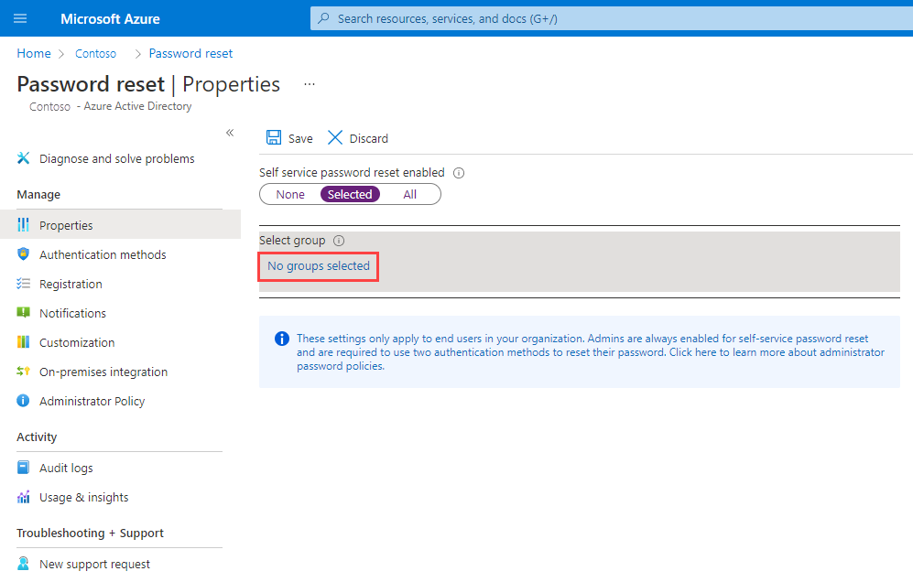](https://learn.microsoft.com/en-us/entra/identity/authentication/media/tutorial-enable-sspr/enable-sspr-for-group.png#lightbox)

1. To enable SSPR for the select users, select **Save**.

## Select authentication methods and registration options

When users need to unlock their account or reset their password, they're prompted for another confirmation method. This extra authentication factor makes sure that Microsoft Entra ID finished only approved SSPR events. You can choose which authentication methods to allow, based on the registration information the user provides.

1. From the menu on the left side of the **Authentication methods** page, set the **Number of methods required to reset** to 2.

To improve security, you can increase the number of authentication methods required for SSPR.

1. Choose the **Methods available to users** that your organization wants to allow. For this tutorial, check the boxes to enable the following methods:
   * Mobile app notification
   * Mobile app code
   * Email
   * Mobile phone

You can enable other authentication methods, like Office phone or Security questions, as needed to fit your business requirements.

1. To apply the authentication methods, select **Save**.

Before users can unlock their account or reset a password, they must register their contact information. Microsoft Entra ID uses this contact information for the different authentication methods set up in the previous steps.

An administrator can manually provide this contact information, or users can go to a registration portal to provide the information themselves. In this tutorial, set up Microsoft Entra ID to prompt the users for registration the next time they sign in.

1. From the menu on the left side of the **Registration** page, select Yes for **Require users to register when signing in**.
2. Set **Number of days before users are asked to reconfirm their authentication information** to 180.

It's important to keep the contact information up to date. If outdated contact information exists when an SSPR event starts, the user may not be able to unlock their account or reset their password.

1. To apply the registration settings, select **Save**.

**Note**

The interruption to request to register contact information during signing in, will only occur, if the conditions configured on the settings are met, and will only apply to users and admin accounts that are enabled to reset passwords using Microsoft Entra self-service password reset.

## Set up notifications and customizations

To keep users informed about account activity, you can set up Microsoft Entra ID to send email notifications when an SSPR event happens. These notifications can cover both regular user accounts and admin accounts. For admin accounts, this notification provides another layer of awareness when a privileged administrator account password is reset using SSPR. Microsoft Entra ID will notify all global admins when someone uses SSPR on an admin account.

1. From the menu on the left side of the **Notifications** page, set up the following options:
   * Set **Notify users on password resets?** option to Yes.
   * Set **Notify all admins when other admins reset their password?** to Yes.
2. To apply the notification preferences, select **Save**.

If users need more help with the SSPR process, you can customize the "Contact your administrator" link. The user can select this link in the SSPR registration process and when they unlock their account or resets their password. To make sure your users get the support needed, we recommend you provide a custom helpdesk email or URL.

1. From the menu on the left side of the **Customization** page, set **Customize helpdesk link** to Yes.
2. In the **Custom helpdesk email or URL** field, provide an email address or web page URL where your users can get more help from your organization, like https://support.contoso.com/
3. To apply the custom link, select **Save**.

## Test self-service password reset

With SSPR enabled and set up, test the SSPR process with a user that's part of the group you selected in the previous section, like Test-SSPR-Group. The following example uses the testuser account. Provide your own user account. It's part of the group you enabled for SSPR in the first section of this tutorial.

**Note**

When you test self-service password reset, use a non-administrator account. By default, Microsoft Entra ID enables self-service password reset for admins. They're required to use two authentication methods to reset their password. For more information, see [**Administrator reset policy differences**](https://learn.microsoft.com/en-us/entra/identity/authentication/concept-sspr-policy#administrator-reset-policy-differences).

1. To see the manual registration process, open a new browser window in InPrivate or incognito mode, and browse to https://aka.ms/ssprsetup. Microsoft Entra ID will direct users to this registration portal when they sign in next time.
2. Sign in with a non-administrator test user, like testuser, and register your authentication methods contact information.
3. Once finished, select the button marked **Looks good** and close the browser window.
4. Open a new browser window in InPrivate or incognito mode, and browse to https://aka.ms/sspr.
5. Enter your non-administrator test users' account information, like testuser, the characters from the CAPTCHA, and then select **Next**.

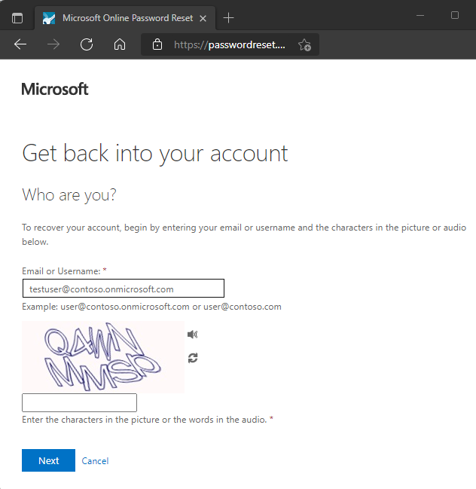

1. Follow the verification steps to reset your password. When finished, you'll receive an email notification that your password was reset.

## Clean up resources

In a later tutorial in this series, you'll set up password writeback. This feature writes password changes from Microsoft Entra SSPR back to an on-premises AD environment. If you want to continue with this tutorial series to set up password writeback, don't disable SSPR now.

If you no longer want to use the SSPR functionality you have set up as part of this tutorial, set the SSPR status to **None** using the following steps:

1. Sign in to the [Microsoft Entra admin center](https://entra.microsoft.com/) as at least an [Authentication Policy Administrator](https://learn.microsoft.com/en-us/entra/identity/role-based-access-control/permissions-reference#authentication-policy-administrator).
2. Browse to **Protection** > **Password reset**.
3. From the **Properties** page, under the option Self service password reset enabled, select **None**.
4. To apply the SSPR change, select **Save**.

## FAQs

This section explains common questions from administrators and end-users who try SSPR:

* Why aren't on-premises password policies displayed during SSPR?

At this time, Microsoft Entra Connect and cloud sync don't support sharing password policy details with the cloud. SSPR only displays the cloud password policy details, and can't show on-premises policies.

* Why do federated users wait up to 2 minutes after they see **Your password has been reset** before they can use passwords that are synchronized from on-premises?

For federated users whose passwords are synchronized, the source of authority for the passwords is on-premises. As a result, SSPR updates only the on-premises passwords. Password hash synchronization back to Microsoft Entra ID is scheduled for every 2 minutes.

* When a newly created user who is pre-populated with SSPR data such as phone and email visits the SSPR registration page, **Don’t lose access to your account!** appears as the title of the page. Why don't other users who have SSPR data pre-populated see the message?

A user who sees **Don’t lose access to your account!** is a member of SSPR/combined registration groups that are configured for the tenant. Users who don’t see **Don’t lose access to your account!** were not part of the SSPR/combined registration groups.

* When some users go through SSPR process and reset their password, why don't they see the password strength indicator?

Users who don’t see weak/strong password strength have synchronized password writeback enabled. Since SSPR can’t determine the password policy of the customer’s on-premises environment, it cannot validate password strength or weakness.

# Enable per-user Microsoft Entra multifactor authentication to secure sign-in events

<https://learn.microsoft.com/en-us/entra/identity/authentication/howto-mfa-userstates>

To secure user sign-in events in Microsoft Entra ID, you can require multifactor authentication. Enabling Microsoft Entra multifactor authentication using Conditional Access policies is the recommended approach to protect users. Conditional Access is a Microsoft Entra ID P1 or P2 feature that lets you apply rules to require MFA as needed in certain scenarios. To get started using Conditional Access, see [Tutorial: Secure user sign-in events with Microsoft Entra multifactor authentication](https://learn.microsoft.com/en-us/entra/identity/authentication/tutorial-enable-azure-mfa).

For Microsoft Entra ID Free tenants without Conditional Access, you can [use security defaults to protect users](https://learn.microsoft.com/en-us/entra/fundamentals/security-defaults). Users are prompted for MFA as needed, but you can't define your own rules to control the behavior.

If needed, you can instead enable each account for per-user Microsoft Entra multifactor authentication. When users are enabled individually, they perform multifactor authentication each time they sign in (with some exceptions, such as when they sign in from trusted IP addresses or when the remember MFA on trusted devices feature is turned on).

Changing [user states](https://learn.microsoft.com/en-us/entra/identity/authentication/howto-mfa-userstates#azure-ad-multi-factor-authentication-user-states) isn't recommended unless your Microsoft Entra ID licenses don't include Conditional Access and you don't want to use security defaults. For more information on the different ways to enable MFA, see [Features and licenses for Microsoft Entra multifactor authentication](https://learn.microsoft.com/en-us/entra/identity/authentication/concept-mfa-licensing).

**Important**

This article details how to view and change the status for per-user Microsoft Entra multifactor authentication. If you use Conditional Access or security defaults, you don't review or enable user accounts using these steps.

Enabling Microsoft Entra multifactor authentication through a Conditional Access policy doesn't change the state of the user. Don't be alarmed if users appear disabled. Conditional Access doesn't change the state.

**Don't enable or enforce per-user Microsoft Entra multifactor authentication if you use Conditional Access policies.**

## Microsoft Entra multifactor authentication user states

A user's state reflects whether an admin has enrolled them in per-user Microsoft Entra multifactor authentication. User accounts in Microsoft Entra multifactor authentication have the following three distinct states:

| **State** | **Description** | **Legacy authentication affected** | **Browser apps affected** | **Modern authentication affected** |
| --- | --- | --- | --- | --- |
| Disabled | The default state for a user not enrolled in per-user Microsoft Entra multifactor authentication. | No | No | No |
| Enabled | The user is enrolled in per-user Microsoft Entra multifactor authentication, but can still use their password for legacy authentication. If the user hasn't yet registered MFA authentication methods, they receive a prompt to register the next time they sign in using modern authentication (such as via a web browser). | No. Legacy authentication continues to work until the registration process is completed. | Yes. After the session expires, Microsoft Entra multifactor authentication registration is required. | Yes. After the access token expires, Microsoft Entra multifactor authentication registration is required. |
| Enforced | The user is enrolled per-user in Microsoft Entra multifactor authentication. If the user hasn't yet registered authentication methods, they receive a prompt to register the next time they sign in using modern authentication (such as via a web browser). Users who complete registration while in the Enabled state are automatically moved to the Enforced state. | Yes. Apps require app passwords. | Yes. Microsoft Entra multifactor authentication is required at sign-in. | Yes. Microsoft Entra multifactor authentication is required at sign-in. |

All users start out Disabled. When you enroll users in per-user Microsoft Entra multifactor authentication, their state changes to Enabled. When enabled users sign in and complete the registration process, their state changes to Enforced. Administrators may move users between states, including from Enforced to Enabled or Disabled.

**Note**

If per-user MFA is re-enabled on a user and the user doesn't re-register, their MFA state doesn't transition from Enabled to Enforced in MFA management UI. The administrator must move the user directly to Enforced.

## View the status for a user

**Tip**

Steps in this article may vary slightly based on the portal you start from.

To view and manage user states, complete the following steps:

1. Sign in to the [Microsoft Entra admin center](https://entra.microsoft.com/) as at least an [Authentication Administrator](https://learn.microsoft.com/en-us/entra/identity/role-based-access-control/permissions-reference#authentication-administrator).
2. Browse to **Identity** > **Users** > **All users**.
3. Select **Per-user MFA**. 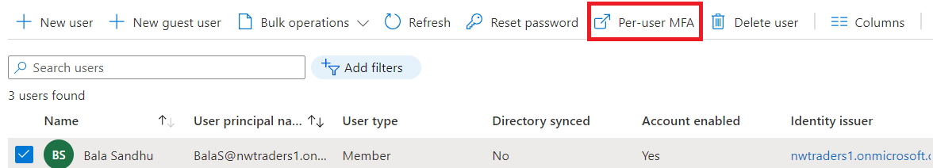
4. A new page opens that displays the user state, as shown in the following example. 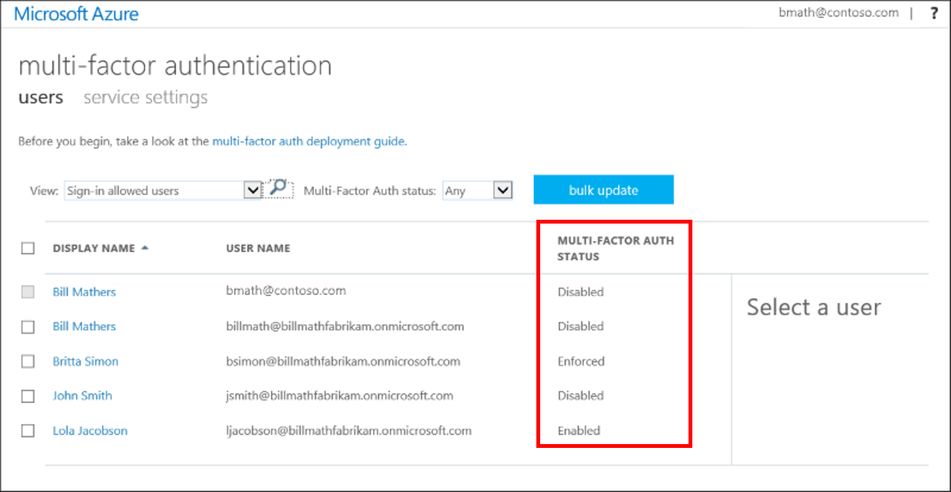

## Change the status for a user

To change the per-user Microsoft Entra multifactor authentication state for a user, complete the following steps:

1. Use the previous steps to [view the status for a user](https://learn.microsoft.com/en-us/entra/identity/authentication/howto-mfa-userstates#view-the-status-for-a-user) to get to the Microsoft Entra multifactor authentication **users** page.
2. Find the user you want to enable for per-user Microsoft Entra multifactor authentication. You might need to change the view at the top to **users**. 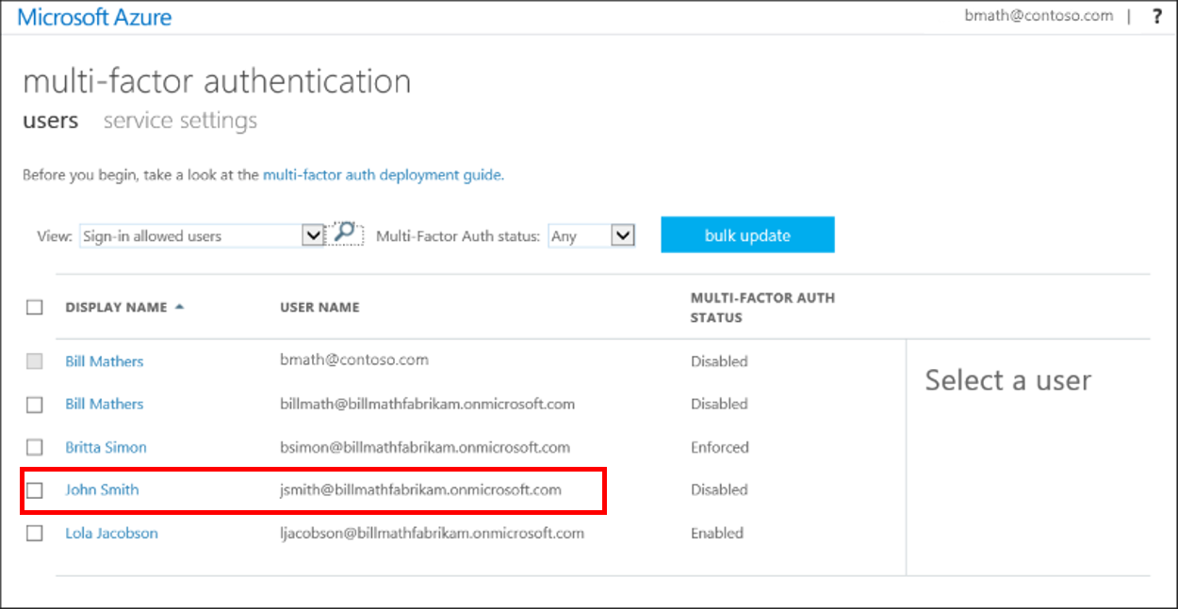
3. Check the box next to the name(s) of the user(s) to change the state for.
4. On the right-hand side, under **quick steps**, choose **Enable** or **Disable**. In the following example, the user John Smith has a check next to their name and is being enabled for use: 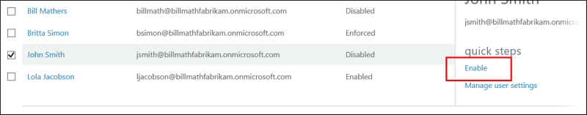

**Tip**

Enabled users are automatically switched to Enforced when they register for Microsoft Entra multifactor authentication. Don't manually change the user state to Enforced unless the user is already registered or if it is acceptable for the user to experience interruption in connections to legacy authentication protocols.

1. Confirm your selection in the pop-up window that opens.

After you enable users, notify them via email. Tell the users that a prompt is displayed to ask them to register the next time they sign in. Also, if your organization uses non-browser apps that don't support modern authentication, they need to create app passwords. For more information, see the [Microsoft Entra multifactor authentication end-user guide](https://support.microsoft.com/account-billing/how-to-use-the-microsoft-authenticator-app-9783c865-0308-42fb-a519-8cf666fe0acc) to help them get started.

### Convert per-user MFA enabled and enforced users to disabled

If your users were enabled using per-user enabled and enforced Microsoft Entra multifactor authentication the following PowerShell can assist you in making the conversion to Conditional Access based Microsoft Entra multifactor authentication.

Run this PowerShell in an ISE window or save as a .PS1 file to run locally. The operation can only be done by using the [MSOnline module](https://learn.microsoft.com/en-us/powershell/module/msonline/#msonline).

PowerShellCopy

# Connect to tenant

Connect-MsolService

# Sets the MFA requirement state

function Set-MfaState {

[CmdletBinding()]

param(

[Parameter(ValueFromPipelineByPropertyName=$True)]

$ObjectId,

[Parameter(ValueFromPipelineByPropertyName=$True)]

$UserPrincipalName,

[ValidateSet("Disabled","Enabled","Enforced")]

$State

)

Process {

Write-Verbose ("Setting MFA state for user '{0}' to '{1}'." -f $ObjectId, $State)

$Requirements = @()

if ($State -ne "Disabled") {

$Requirement =

[Microsoft.Online.Administration.StrongAuthenticationRequirement]::new()

$Requirement.RelyingParty = "*"

$Requirement.State = $State

$Requirements += $Requirement

}

Set-MsolUser -ObjectId $ObjectId -UserPrincipalName $UserPrincipalName `

-StrongAuthenticationRequirements $Requirements

}

}

# Disable MFA for all users

Get-MsolUser -All | Set-MfaState -State Disabled

# Password policies and account restrictions in Microsoft Entra ID

In Microsoft Entra ID, there's a password policy that defines settings like the password complexity, length, or age. There's also a policy that defines acceptable characters and length for usernames.

When self-service password reset (SSPR) is used to change or reset a password in Microsoft Entra ID, the password policy is checked. If the password doesn't meet the policy requirements, the user is prompted to try again. Azure administrators have some restrictions on using SSPR that are different to regular user accounts, and there are minor exceptions for trial and free versions of Microsoft Entra ID.

This article describes the password policy settings and complexity requirements associated with user accounts. It also covers how to use PowerShell to check or set password expiration settings.

## Username policies

Every account that signs in to Microsoft Entra ID must have a unique user principal name (UPN) attribute value associated with their account. In hybrid environments with an on-premises Active Directory Domain Services (AD DS) environment synchronized to Microsoft Entra ID using Microsoft Entra Connect, by default the Microsoft Entra UPN is set to the on-premises UPN.

The following table outlines the username policies that apply to both on-premises AD DS accounts that are synchronized to Microsoft Entra ID, and for cloud-only user accounts created directly in Microsoft Entra ID:

| **Property** | **UserPrincipalName requirements** |
| --- | --- |
| Characters allowed | A – Z a - z 0 – 9 ' . - _ ! # ^ ~ |
| Characters not allowed | Any "@" character that's not separating the username from the domain. Can't contain a period character "." immediately preceding the "@" symbol |
| Length constraints | The total length must not exceed 113 characters There can be up to 64 characters before the "@" symbol There can be up to 48 characters after the "@" symbol |

## Microsoft Entra password policies

A password policy is applied to all user accounts that are created and managed directly in Microsoft Entra ID. Some of these password policy settings can't be modified, though you can [configure custom banned passwords for Microsoft Entra password protection](https://learn.microsoft.com/en-us/entra/identity/authentication/tutorial-configure-custom-password-protection) or account lockout parameters.

By default, an account is locked out after 10 unsuccessful sign-in attempts with the wrong password. The user is locked out for one minute. Further incorrect sign-in attempts lock out the user for increasing durations of time. [Smart lockout](https://learn.microsoft.com/en-us/entra/identity/authentication/howto-password-smart-lockout) tracks the last three bad password hashes to avoid incrementing the lockout counter for the same password. If someone enters the same bad password multiple times, they won't get locked out. You can define the smart lockout threshold and duration.

The Microsoft Entra password policy doesn't apply to user accounts synchronized from an on-premises AD DS environment using Microsoft Entra Connect, unless you enable EnforceCloudPasswordPolicyForPasswordSyncedUsers.

The following Microsoft Entra password policy options are defined. Unless noted, you can't change these settings:

| **Property** | **Requirements** |
| --- | --- |
| Characters allowed | A – Z a - z 0 – 9 @ # $ % ^ & * - _ ! + = [ ] { } | \ : ' , . ? / ` ~ " ( ) ; < > Blank space |
| Characters not allowed | Unicode characters |
| Password restrictions | A minimum of 8 characters and a maximum of 256 characters. Requires three out of four of the following types of characters: - Lowercase characters - Uppercase characters - Numbers (0-9) - Symbols (see the previous password restrictions) |
| Password expiry duration (Maximum password age) | Default value: **90** days. If the tenant was created after 2021, it has no default expiration value. You can check current policy with [Get-MsolPasswordPolicy](https://learn.microsoft.com/en-us/powershell/module/msonline/get-msolpasswordpolicy). The value is configurable by using the Set-MsolPasswordPolicy cmdlet from the Azure AD module for PowerShell. |
| Password expiry (Let passwords never expire) | Default value: **false** (indicates that passwords have an expiration date). The value can be configured for individual user accounts by using the Set-MsolUser cmdlet. |
| Password change history | The last password can't be used again when the user changes a password. |
| Password reset history | The last password can be used again when the user resets a forgotten password. |

## Administrator reset policy differences

By default, administrator accounts are enabled for self-service password reset, and a strong default two-gate password reset policy is enforced. This policy may be different from the one you have defined for your users, and this policy can't be changed. You should always test password reset functionality as a user without any Azure administrator roles assigned.

The two-gate policy requires two pieces of authentication data, such as an email address, authenticator app, or a phone number, and it prohibits security questions. Office and mobile voice calls are also prohibited for trial or free versions of Microsoft Entra ID.

A two-gate policy applies in the following circumstances:

* All the following Azure administrator roles are affected:
  + Application administrator
  + Application proxy service administrator
  + Authentication administrator
  + Billing administrator
  + Compliance administrator
  + Device administrators
  + Directory synchronization accounts
  + Directory writers
  + Dynamics 365 administrator
  + Exchange administrator
  + Global administrator or company administrator
  + Helpdesk administrator
  + Intune administrator
  + Mailbox Administrator
  + Microsoft Entra Joined Device Local Administrator
  + Partner Tier1 Support
  + Partner Tier2 Support
  + Password administrator
  + Power BI service administrator
  + Privileged Authentication administrator
  + Privileged role administrator
  + Security administrator
  + Service support administrator
  + SharePoint administrator
  + Skype for Business administrator
  + User administrator
* If 30 days have elapsed in a trial subscription; or
* A custom domain has been configured for your Microsoft Entra tenant, such as contoso.com; or
* Microsoft Entra Connect is synchronizing identities from your on-premises directory

You can disable the use of SSPR for administrator accounts using the [Update-MgPolicyAuthorizationPolicy](https://learn.microsoft.com/en-us/powershell/module/microsoft.graph.identity.signins/update-mgpolicyauthorizationpolicy) PowerShell cmdlet. The -AllowedToUseSspr:$true|$false parameter enables/disables SSPR for administrators. Policy changes to enable or disable SSPR for administrator accounts can take up to 60 minutes to take effect.

### Exceptions

A one-gate policy requires one piece of authentication data, such as an email address or phone number. A one-gate policy applies in the following circumstances:

* It's within the first 30 days of a trial subscription

-Or-

* A custom domain isn't configured (the tenant is using the default *.onmicrosoft.com, which isn't recommended for production use) and Microsoft Entra Connect isn't synchronizing identities.

## Password expiration policies

A Global Administrator or User Administrator can use the [Azure Active Directory module for PowerShell](https://learn.microsoft.com/en-us/powershell/module/Azuread/) to set user passwords not to expire.

You can also use PowerShell cmdlets to remove the never-expires configuration or to see which user passwords are set to never expire.

This guidance applies to other providers, such as Intune and Microsoft 365, which also rely on Microsoft Entra ID for identity and directory services. Password expiration is the only part of the policy that can be changed.

**Note**

By default only passwords for user accounts that aren't synchronized through Microsoft Entra Connect can be configured to not expire. For more information about directory synchronization, see [**Connect AD with Microsoft Entra ID**](https://learn.microsoft.com/en-us/entra/identity/hybrid/connect/how-to-connect-password-hash-synchronization#password-expiration-policy).

### Set or check the password policies by using PowerShell

To get started, [download and install the Azure AD PowerShell module](https://learn.microsoft.com/en-us/powershell/module/azuread/) and [connect it to your Microsoft Entra tenant](https://learn.microsoft.com/en-us/powershell/module/azuread/connect-azuread#examples).

After the module is installed, use the following steps to complete each task as needed.

### Check the expiration policy for a password

1. Open a PowerShell prompt and [connect to your Microsoft Entra tenant](https://learn.microsoft.com/en-us/powershell/module/azuread/connect-azuread#examples) using a Global Administrator or User Administrator account.
2. Run one of the following commands for either an individual user or for all users:
   * To see if a single user's password is set to never expire, run the following cmdlet. Replace <user ID> with the user ID of the user you want to check, such as driley@contoso.onmicrosoft.com:

PowerShellCopy

Get-AzureADUser -ObjectId <user ID> | Select-Object @{N="PasswordNeverExpires";E={$_.PasswordPolicies -contains "DisablePasswordExpiration"}}

* + To see the **Password never expires** setting for all users, run the following cmdlet:

PowerShellCopy

Get-AzureADUser -All $true | Select-Object UserPrincipalName, @{N="PasswordNeverExpires";E={$_.PasswordPolicies -contains "DisablePasswordExpiration"}}

### Set a password to expire

1. Open a PowerShell prompt and [connect to your Microsoft Entra tenant](https://learn.microsoft.com/en-us/powershell/module/azuread/connect-azuread#examples) using a Global Administrator or User Administrator account.
2. Run one of the following commands for either an individual user or for all users:
   * To set the password of one user so that the password expires, run the following cmdlet. Replace <user ID> with the user ID of the user you want to check, such as driley@contoso.onmicrosoft.com

PowerShellCopy

Set-AzureADUser -ObjectId <user ID> -PasswordPolicies None

* + To set the passwords of all users in the organization so that they expire, use the following cmdlet:

PowerShellCopy

Get-AzureADUser -All $true | Set-AzureADUser -PasswordPolicies None

### Set a password to never expire

1. Open a PowerShell prompt and [connect to your Microsoft Entra tenant](https://learn.microsoft.com/en-us/powershell/module/azuread/connect-azuread#examples) using a Global Administrator or User Administrator account.
2. Run one of the following commands for either an individual user or for all users:
   * To set the password of one user to never expire, run the following cmdlet. Replace <user ID> with the user ID of the user you want to check, such as driley@contoso.onmicrosoft.com

PowerShellCopy

Set-AzureADUser -ObjectId <user ID> -PasswordPolicies DisablePasswordExpiration

* + To set the passwords of all the users in an organization to never expire, run the following cmdlet:

PowerShellCopy

Get-AzureADUser -All $true | Set-AzureADUser -PasswordPolicies DisablePasswordExpiration

1. **Warning**
2. Passwords set to -PasswordPolicies DisablePasswordExpiration still age based on the pwdLastSet attribute. Based on the pwdLastSet attribute, if you change the expiration to -PasswordPolicies None, all passwords that have a pwdLastSet older than 90 days require the user to change them the next time they sign in. This change can affect a large number of users.

# #GROUPS :

# Manage Microsoft Entra groups and group membership

Microsoft Entra groups are used to manage users that all need the same access and permissions to resources, such as potentially restricted apps and services. Instead of adding special permissions to individual users, you create a group that applies the special permissions to every member of that group.

This article covers basic group scenarios where a single group is added to a single resource and users are added as members to that group. For more complex scenarios like dynamic memberships and rule creation, see the [Microsoft Entra user management documentation](https://learn.microsoft.com/en-us/entra/identity/users/).

Before adding groups and members, [learn about groups and membership types](https://learn.microsoft.com/en-us/entra/fundamentals/concept-learn-about-groups) to help you decide which options to use when you create a group.

## Create a basic group and add members

**Tip**

Steps in this article may vary slightly based on the portal you start from.

You can create a basic group and add your members at the same time using the Microsoft Entra admin center. Microsoft Entra roles that can manage groups include **Groups Administrator**, **User Administrator**, **Privileged Role Administrator**, or **Global Administrator**. Review the [appropriate Microsoft Entra roles for managing groups](https://learn.microsoft.com/en-us/entra/identity/role-based-access-control/delegate-by-task#groups)

To create a basic group and add members:

1. Sign in to the [Microsoft Entra admin center](https://entra.microsoft.com/) as at least a [Groups Administrator](https://learn.microsoft.com/en-us/entra/identity/role-based-access-control/permissions-reference#groups-administrator).
2. Browse to **Identity** > **Groups** > **All groups**.
3. Select **New group**.

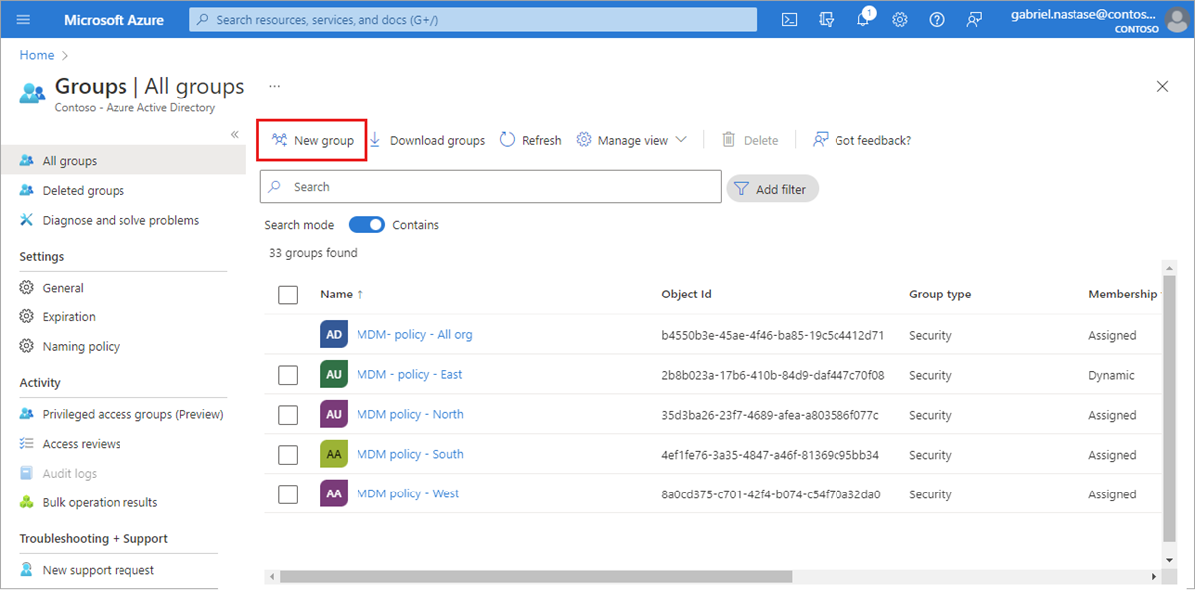

1. Select a **Group type**. For more information on group types, see the [learn about groups and membership types](https://learn.microsoft.com/en-us/entra/fundamentals/concept-learn-about-groups) article.
   * Selecting the **Microsoft 365** Group type enables the **Group email address** option.
2. Enter a **Group name.** Choose a name that you'll remember and that makes sense for the group. A check will be performed to determine if the name is already in use. If the name is already in use, you'll be asked to change the name of your group.
   * The name of the group can't start with a space. Starting the name with a space prevents the group from appearing as an option for steps such as adding role assignments to group members.
3. **Group email address**: Only available for Microsoft 365 group types. Enter an email address manually or use the email address built from the Group name you provided.
4. **Group description.** Add an optional description to your group.
5. Switch the **Microsoft Entra roles can be assigned to the group** setting to yes to use this group to assign Microsoft Entra roles to members.
   * This option is only available with P1 or P2 licenses.
   * You must have the **Privileged Role Administrator** or **Global Administrator** role.
   * Enabling this option automatically selects **Assigned** as the Membership type.
   * The ability to add roles while creating the group is added to the process.
   * [Learn more about role-assignable groups](https://learn.microsoft.com/en-us/entra/identity/role-based-access-control/groups-create-eligible).
6. Select a **Membership type.** For more information on membership types, see the [learn about groups and membership types](https://learn.microsoft.com/en-us/entra/fundamentals/concept-learn-about-groups) article.
7. Optionally add **Owners** or **Members**. Members and owners can be added after creating your group.
   * Select the link under **Owners** or **Members** to populate a list of every user in your directory.
   * Choose users from the list and then select the **Select** button at the bottom of the window.

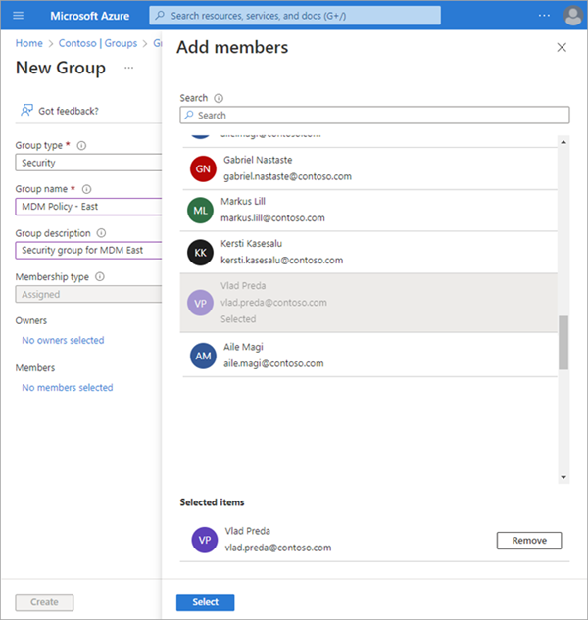

1. Select **Create**. Your group is created and ready for you to manage other settings.

### Turn off group welcome email

A welcome notification is sent to all users when they're added to a new Microsoft 365 group, regardless of the membership type. When an attribute of a user or device changes, all dynamic group rules in the organization are processed for potential membership changes. Users who are added then also receive the welcome notification. You can turn off this behavior in [Exchange PowerShell](https://learn.microsoft.com/en-us/powershell/module/exchange/set-unifiedgroup).

## Add or remove members and owners

Members and owners can be added to and removed from existing groups. The process is the same for members and owners. You'll need the **Groups Administrator** or **User Administrator** role to add and remove members and owners.

Need to add multiple members at one time? Learn about the [add members in bulk](https://learn.microsoft.com/en-us/entra/identity/users/groups-bulk-import-members) option.

### Add members or owners of a group

1. Sign in to the [Microsoft Entra admin center](https://entra.microsoft.com/) as at least a [Groups Administrator](https://learn.microsoft.com/en-us/entra/identity/role-based-access-control/permissions-reference#groups-administrator).
2. Browse to **Identity** > **Groups** > **All groups**.
3. Select the group you need to manage.
4. Select either **Members** or **Owners**.

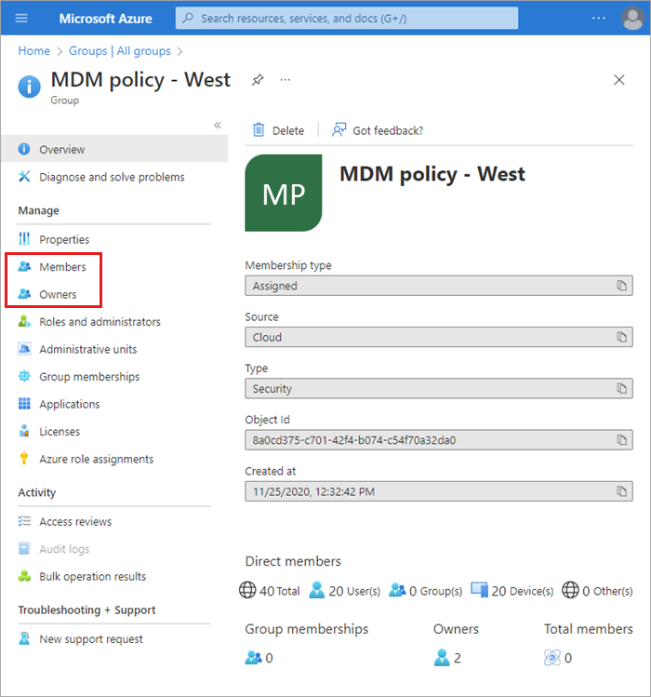

1. Select **+ Add** (members or owners).
2. Scroll through the list or enter a name in the search box. You can choose multiple names at one time. When you're ready, select the **Select** button.

The **Group Overview** page updates to show the number of members who are now added to the group.

### Remove members or owners of a group

1. Sign in to the [Microsoft Entra admin center](https://entra.microsoft.com/) as at least a [Groups Administrator](https://learn.microsoft.com/en-us/entra/identity/role-based-access-control/permissions-reference#groups-administrator).
2. Browse to **Identity** > **Groups** > **All groups**.
3. Select the group you need to manage.
4. Select either **Members** or **Owners**.
5. Check the box next to a name from the list and select the **Remove** button.

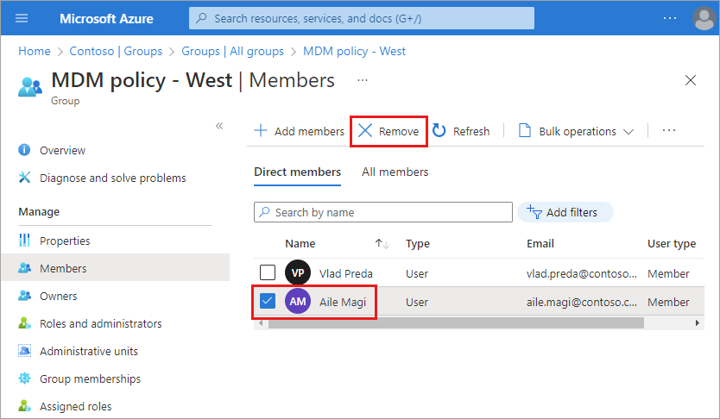

## Edit group settings

You can edit a group's name, description, or membership type. You'll need the **Groups Administrator** or **User Administrator** role to edit a group's settings.

To edit your group settings:

1. Sign in to the [Microsoft Entra admin center](https://entra.microsoft.com/) as at least a [Groups Administrator](https://learn.microsoft.com/en-us/entra/identity/role-based-access-control/permissions-reference#groups-administrator).
2. Browse to **Identity** > **Groups** > **All groups**.
3. Scroll through the list or enter a group name in the search box. Select the group you need to manage.
4. Select **Properties** from the side menu.

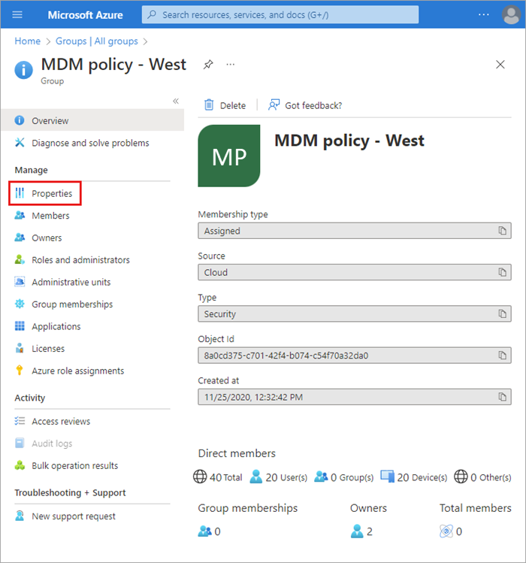

1. Update the **General settings** information as needed, including:
   * **Group name.** Edit the existing group name.
   * **Group description.** Edit the existing group description.
   * **Group type.** You can't change the type of group after it's been created. To change the **Group type**, you must delete the group and create a new one.
   * **Membership type.** Change the membership type. If you enabled the **Microsoft Entra roles can be assigned to the group** option, you can't change the membership type. For more info about the available membership types, see the [learn about groups and membership types](https://learn.microsoft.com/en-us/entra/fundamentals/concept-learn-about-groups) article.
   * **Object ID.** You can't change the Object ID, but you can copy it to use in your PowerShell commands for the group. For more info about using PowerShell cmdlets, see [Microsoft Entra cmdlets for configuring group settings](https://learn.microsoft.com/en-us/entra/identity/users/groups-settings-v2-cmdlets).

## Add or remove a group from another group

You can add an existing Security group to another Security group (also known as nested groups). Depending on the group types, you can add a group as a member of another group, just like a user, which applies settings like roles and access to the nested groups. You'll need the **Groups Administrator** or **User Administrator** role to edit group membership.

We currently don't support:

* Adding groups to a group synced with on-premises Active Directory.
* Adding Security groups to Microsoft 365 groups.
* Adding Microsoft 365 groups to Security groups or other Microsoft 365 groups.
* Assigning apps to nested groups.
* Applying licenses to nested groups.
* Adding distribution groups in nesting scenarios.
* Adding security groups as members of mail-enabled security groups.
* Adding groups as members of a role-assignable group.

### Add a group to another group

1. Sign in to the [Microsoft Entra admin center](https://entra.microsoft.com/) as at least a [Groups Administrator](https://learn.microsoft.com/en-us/entra/identity/role-based-access-control/permissions-reference#groups-administrator).
2. Browse to **Identity** > **Groups** > **All groups**.
3. On the **All groups** page, search for and select the group you want to become a member of another group.

**Note**

You only can add your group as a member to one other group at a time. Wildcard characters aren't supported in the **Select Group** search box.

1. On the group Overview page, select **Group memberships** from the side menu.
2. Select **+ Add memberships**.
3. Locate the group you want your group to be a member of and choose **Select**.

For this exercise, we're adding "MDM policy - West" to the "MDM policy - All org" group. The "MDM - policy - West" group will have the same access as the "MDM policy - All org" group.

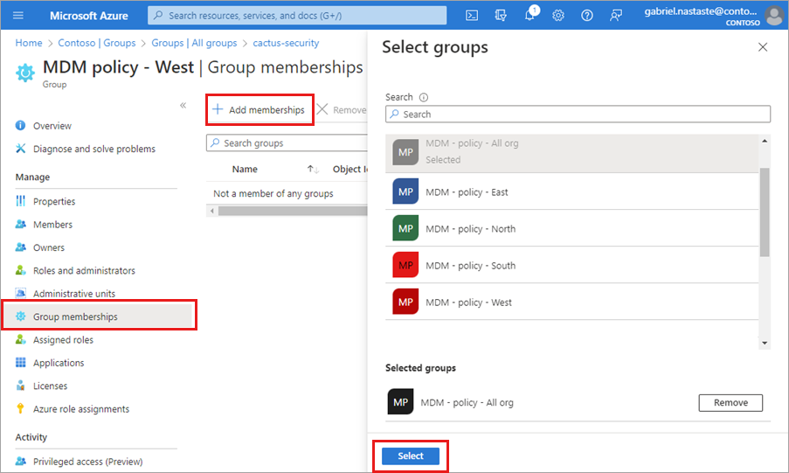

Now you can review the "MDM policy - West - Group memberships" page to see the group and member relationship.

For a more detailed view of the group and member relationship, select the parent group name (MDM policy - All org) and take a look at the "MDM policy - West" page details.

### Remove a group from another group

You can remove an existing Security group from another Security group; however, removing the group also removes any inherited access for its members.

1. On the **All groups** page, search for and select the group you need to remove as a member of another group.
2. On the group Overview page, select **Group memberships**.
3. Select the parent group from the **Group memberships** page.
4. Select **Remove**.

For this exercise, we're now going to remove "MDM policy - West" from the "MDM policy - All org" group.

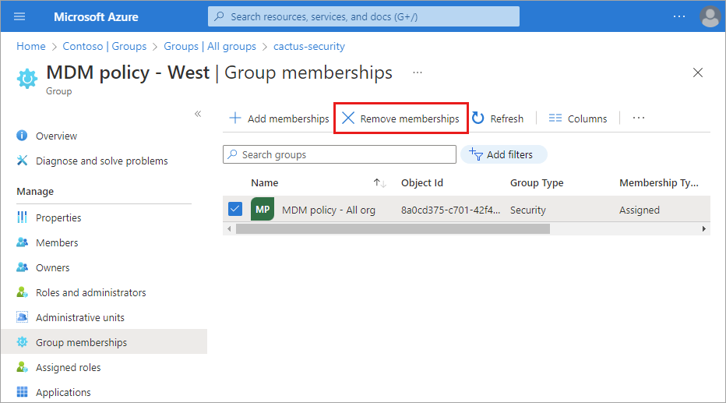

## Delete a group

You can delete a group for any number of reasons, but typically it will be because you:

* Choose the incorrect **Group type** option.
* Created a duplicate group by mistake.
* No longer need the group.

1. Sign in to the [Microsoft Entra admin center](https://entra.microsoft.com/) as at least a [Groups Administrator](https://learn.microsoft.com/en-us/entra/identity/role-based-access-control/permissions-reference#groups-administrator).
2. Browse to **Identity** > **Groups** > **All groups**.
3. Search for and select the group you want to delete.
4. Select **Delete**.

**#Get started with External Identities**

External Identities is a set of capabilities that enabled organizations to secure and manage any external user, including customers and partners beyond your organizational boundaries. Building on the B2B collaboration capabilities in Microsoft Entra ID, External Identities supports additional ways to interact and connect with users outside of your organization.

Learn more



#### Set up how you want to collaborate

Configure how external users can access your resources, how these users get invited and any restrictions you want to set.

[Learn more](https://learn.microsoft.com/azure/active-directory/external-identities/delegate-invitations?WT.mc_id=Portal-Microsoft_AAD_IAM)

2)



#### Set up identity providers

Configure the way you want to authenticate to access your resources, including social providers like Facebook and Google.

[Learn more](https://learn.microsoft.com/azure/active-directory/external-identities/identity-providers?WT.mc_id=Portal-Microsoft_AAD_IAM)

3)



#### Self-service sign-up

With a self-service sign-up user flow, you can create a sign-up experience for external users who want to access your apps.

[Learn more](https://learn.microsoft.com/azure/active-directory/external-identities/self-service-sign-up-overview?WT.mc_id=Portal-Microsoft_AAD_IAM)

4)



#### Invite external users to collaborate

Invite external users you want to collaborate with.

[Learn more](https://learn.microsoft.com/azure/active-directory/external-identities/redemption-experience?WT.mc_id=Portal-Microsoft_AAD_IAM)

5)



#### Protect your applications & brand

Use premium security capabilities in Microsoft Entra Conditional Access to ensure that external users accessing your resources are doing so in a way that meets your organization's security policies.

[Learn more](https://learn.microsoft.com/azure/active-directory/external-identities/conditional-access?WT.mc_id=Portal-Microsoft_AAD_IAM)

6)



#### Manage provisioning and access

Identity Governance provides all the capabilities you need to manage external users in your organization. This provides a quick way to onboard and offboard users with Entitlement Management, along with using Access Reviews to ensure that the people who have access still require it.

[Learn more](https://learn.microsoft.com/azure/active-directory/governance/identity-governance-overview?WT.mc_id=Portal-Microsoft_AAD_IAM)